Title : Peak Nasal Inspiratory Flow: reference value for Asian Ethnic.

Authors :

Pongsakorn Tantilipikorn, M.D.

Nattavit Meekul, M.D.

Triphoom Suwannavej, M.D.

Bangorn Pinkaew, M.Sc.

Wannachai xxxx, B.Sc

Chaweewan Bunnag, M.D.

Bankit Thinkumrop, Ph.D.

Objectives

To establish normal value of Peak Nasal Inspiratory Flow (PNIF) for Asian Ethnic. To assess correlation of PNIF normal value with sex, age, weight, height and body mass index (BMI) in adults. To assess the correlation between PNIF and Nasal Airway Resistance (NAR) and Nasal Airflow, which are measured by Active Anterior Rhinomanometry (RMM).

Study design: Prospective descriptive and inferential study.

Methods PNIF and RMM were measured in 180 healthy Thai adults who fulfilled the study criteria with age ranging from 15 to 70 years. PNIF and RMM were performed before and after decongestion, using a portable Youlten peak flow meter (Clement Clark International, UK)

Results: One hundred and eighty patients were included (82 male , 98 female). The mean of age was 38.94+13.73 years, weight 61.85+14.78 kg., height 162.93+8.21cm. and BMI 23.17+4.66. The mean of the PNIF was 116.21+38.44 L/min before decongestion and 132.7+47.6 L/min post decongestion. There was statistical significant correlation (p < 0.0001) between PNIF with sex,; and no correlation with age weight, height and BMI. The value of PNIF was significantly higher in male subjects. The mean PNIF of male and female are 139.02+37.62 L/min and 97.11+27.13 L/min, respectively.

Conclusion: PNIF is a useful method to evaluate the nasal patency in both primary and secondary care centers. The study provides normative data for Thai and Asian population. The male PNIF has significant different than female.

Keyword : Peak Nasal Inspiratory Flow, Rhinomanometry, nasal obstruction, normal values, sex, age, weight, height, body mass index (BMI).

Introduction

Nasal obstruction is one of the most common complaints in clinical practice. It can be categorized into two groups as the mucosal or the structural causes. The mucosal etiology is more common than the other due to high prevalence of upper respiratory traction infection and allergic inflammation.

Because of the “chronic” natural course of allergic disease and its high prevalence rate all over the world, physicians have to treat and monitor the patients in a long period of time. Moreover, the allergic disease affects quality of life (QoL) of the patient with the equal significant as the other disease such as hypertension or heart disease. Among the various allergic symptoms, nasal obstruction is the most common one and is the primary symptoms the leads to the other consequences , for instance, sinusitis, chronic mouth breathing, sleep-disorder problems, etc.

The objective evaluation of nasal obstruction can be made be many ways. It can be done by measuring the nasal airflow/airway resistance or minimal cross sectional area (MCA)/nasal volume (NV). The airflow/resistance can be measured by Rhinomanometer (RMM), and the MCA/NV can be measured by Acoustic Rhinometer (ARM).

Previous studies of RMM and ARM show good correlation with the nasal obstruction symptoms. Both methods have been utilized for not only the monitoring the response of treatment but also as the criteria of gold standard diagnosis of allergic rhinitis, which is the nasal provocation test. The advantage of RMM is it ability of providing the value of airflow for both sides of nose as a single value by mathematical calculation. But both RMM&ARM methods are *relatively expensive*, complex to use and *time-consuming,* because of the degree of patient cooperation and require *experience technician.*

In 1980, Youlten presented the **peak nasal inspiratory flow meter (PNIF**), which is modification of *Wright peak flow meter* and consists of a face mask which the patient applies over the nose (without touching it) with the mouth closed

The **patient sniff air through the nose** and the peak flow is recorded by a cursor

*Giancarlo Ottaviano* was studied at the Royal National Throat Nose and Ear Hospital, London, UK, to establish baseline **normal values in adult subjects(1)**

Purpose of this study is to

1. Establish **normative PNIF** data for a healthy **Thai adult** population and imply those value as a **reference for Asian Ethnic**.

2. Perform correlation studies of **PNIF** normal values with **age**, **height**, **weight** and **sex** in adults.

**3. Comparison** of PNIF with the established quantitative tests of nasal obstruction by using Rhinomanometry (RMM) as the reference.

Method

Study design: **Descriptive study** and correlation study

Study population: **180 healthy** Thai volunteers

Inclusion criteria

Age>15 years and Age <70 years

No symptom of nasal congestion

No history of asthma, rhinitis

No structural abnormalities of nasal cavities

Exclusion criteria

Previous surgery to the nose and paranasal sinuses

Take inhale nasal corticosteroid within 2 weeks or oral corticosteroid within 1 week

Take nasal decongestant within 1 day

Smoking

Methods of measurement by A Portable Youlten flow meter (Clement Clark International) was used for the measure of peak inspiratory nasal flow. The masks attached to the spirometer were chosen to fit tightly on each subject’s face without touching the nose and were cleaned with swabs saturated with alcohol and dried between every subject tested

All subjects were tested while sitting and were encouraged to inhale as hard and fast as they could through the mask keeping the mouth closed starting from the end of a full expiration

*Three satisfactory maximal inspirations* were obtained and the highest of the three results was taken as the PNIF

After PNIF was tested, 3%Ephidrine solution was sprayed in both nasal cavites and wait for 5 minuites then repeated again and wait for 5 minuites

After 3%Ephidrine solution ingestion, all subjects were also tested with a Portable Youlten flow meter with the same techniques.

The first 100 subjects were tested for PNIF and RMM, for calculating the association with both methods.

180 subjects without any nasal complaints

Subject# 101-180: Measure PNIF without RMM

Subject # 1-100: Measure PNIF by peak flow meter AND measure of resistant and flow by RMM

Results.

Table 1 : Subjects demographic data. (N=180)

|  |  |  |  |
| --- | --- | --- | --- |
|  | Male  (n=82) | Female  (n=98) | Total  (n=180) |
| Age (Yr) | 39.18±14.04 | 38.74±13.53 | 38.94±13.73 |
| Height (cm) | 169.18±6.06 | 157.69±5.73 | 162.93±8.21 |
| Weight (kg) | 71.32±13.48 | 53.92±10.59 | 61.85±14.78 |
| BMI | 24.91±4.51 | 21.71±4.28 | 23.16±4.66 |

Table 2: Peak nasal inspiratory flow rate (PNIF , L/sec) of male and female subject (N=180)

|  |  |  |  |
| --- | --- | --- | --- |
|  | Male  (n=82) | Female  (n=98) | p-value |
| **PNIF1** | 119.33±33.13 | 82.96±23.99 |  |
| **PNIF2** | 129.45±36.12 | 85.38±27.81 |  |
| **PNIF3** | 132.07±37.89 | 91.60±30.42 |  |
| **PNIF max** | 139.02±37.62 | 97.11±27.13 | <0.0001 |

Table 3: Peak nasal inspiratory flow rate (PNIF) and the associated factors (N=180)

|  |  |  |
| --- | --- | --- |
|  | PNIF | |
|  | r | p |
| Age |  | 0.37 |
| Weight |  | 0.85 |
| Height |  | 0.61 |
| BMI |  | 0.96 |
| Sex | 0.55 | <0.001 |

Table 4: Nasal airway resistance value by rhinomanometry (RMM), (N=100)

|  |  |  |
| --- | --- | --- |
| NAR (Pa/cc/sec) | Before Decongestion | After Decongestion |
| Right Side | 0.44±0.26 | 0.29±0.16 |
| Left Side | 0.45±0.24 | 0.30±0.19 |
| Total | 0.20±0.10 | 0.14±0.06 |

Table 5: Peak nasal inspiratory flow rate (PNIF) and Rhinomanometry values. (N=180)

|  |  |  |
| --- | --- | --- |
|  | PNIF | |
|  | p | r |
| Airway resistance | -0.27 | 0.0075 |
| Nasal Flow Rate | 0.26 | 0.0094 |

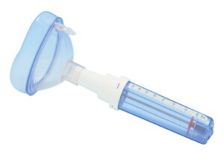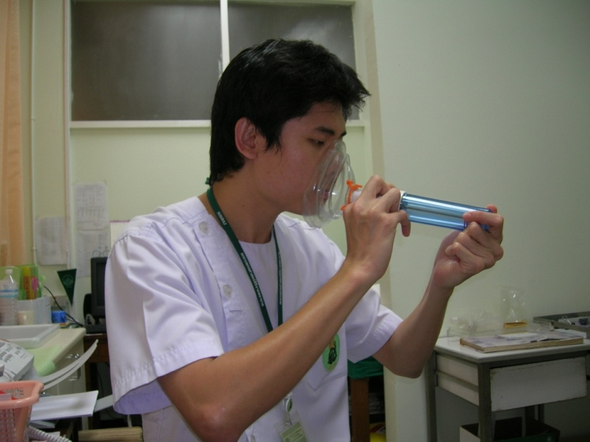

Discussions

Conclusion

References:

1. Ashan G, Drettner B.Ronge HE.A new technique for measuring nasal airflow resistance to breathing, illustrated by the effect of histamine and physical effort. Ann Acad Regiae Sci Ups 1995; 2:111-26.
2. Youlten LJF. The peak nasal inspiratory flow meter: a new instrument for the assessment of the response to immunotherapy in a seasonal allergic rhinitis.
3. Allergol Immunopathol.1980; 8: 344-46.
4. Holmstorm M, Scadding GK, Lund VJ, Darby YC. Assessment of nasal obstruction. A comparison between rhinomanometry and nasal inspiratory peak flow. Rhinology1990; 28:191-6.
5. Fairley JW, Durham LH, Ell SR. Correlation of subjective sensation of nasal patency with nasal inspiratory rate. Clin Otolaryngol 1993; 18:19-22.
6. Wilson A. Airflow obstruction and Peak Nasal Inspiratory Flow (PNIF). Data from http://a.m.wilson@dundee.ac.uk
7. Prescott CAJ, Prescott KE. Peak Nasal Inspiratory Flow measurement: an investigation in children. Int J Pediatr Otorhinolaryngol1995; 32:137-41.
8. Giancarlo O, Glenis K, Stuart C, Lund VJ. Peak Nasal Inspiratory Flow; normal range in adult population. Am J Rhinology.2006; 44:32-5.
9. Bunnag C, Jareoncharsri P, Dachpunpour P, Vitavasiri A. Nasal airway resistance in asymptomatic Thai population. Siriraj Hosp Gaz 1995; 47:123-8.
10. Pongsakorn T, Jareoncharsri P, Bunnag C, Voraprayoon S, Clement PA. Acoustic rhinometry of the Asian noses. Am J Rhinology 2008; 22:1-4.
11. Blomgen K, Simola M. Hytonen M. Pitkaranta A.(2003) Peak nasal inspiratory and expiratory flow measurements – practical tools in primary care? Rhinology 2003; 41: 206-210.

Reference (EndNote)

1. Ottaviano G, Scadding GK, Coles S, Lund VJ. Peak nasal inspiratory flow; normal range in adult population. Rhinology. 2006 Mar;44(1):32-5.