TITLE PAGE

Title: Effect of grandparental child rearing on cognitive development among 12-month-old Thai infants: the prospective cohort study of Thai children

Authors: Sukanya Kansin¹, Bandit Thinkamrop² , <Others to be added>
Affiliations:
¹ The degree of doctor of Public Health , Faculty of Public Health, Khon Kaen University, Thailand
² Department of Biostatistics and Demography, Faculty of Public Health, Khon Kaen University, Thailand

Corresponding authors:
Name: Bandit Thinkhamrop
Address: Department of Biostatistics and Demography, Faculty of Public Health, Khon Kaen University, Khon Kaen, 40002, Thailand
Telephone: +66-85-0011123
Fax: +66-43-362075
e-Mail: bandit@kku.ac.th

Type of contribution: Original research results

Running title: Rates and determinants of cognitive development among 12-month-old Thai infants
Number of words in the abstract: 362

Number of words in the text: 4,883

Number of tables: 3

Number of figures: 2

ABSTRACT

Background: Thai society changed to modernization, parents of the child immigrate to work in the industrialized or urban areas transferred child rearing to others include a grandparents. In the year 2009 children being reared by grandparents 26.7 %.The review literature found that most of grandparents emphasized focus on promoting the physical. But in the learning process, particular, the development of cognitive they could not support the children well. And in children most studies of styles and factors related to child rearing. However there are few studies on the child development and dimensions of child rearing on the cognitive development

Objective: Aim 1: study children’s cognitive development
Aim 2: study effect of grandparental child rearing and child rearing dimensions on the cognitive development among 12-month-old Thai infants.

Methods: This study is part of the prospective cohort study of Thailand (PCTC) conducted in 2005.The PCTC enrolled 4,225 children from rural districts (one district in each region-North, Northeast, South and Central) and Bangkok (specifically, the catchment for Ramathibodi University Hospital), who were born between October 15, 2000 and September 14, 2002. Data were collected via interviews or extracted from existing records. Demographic characteristics were described using mean and standard deviation for continuous variable and frequency and percentage for categorical variable. Each dimensions of child rearing was quantified by percentage, estimated by the 95% confidence (CI) were also calculated for each of these items. Bivariate logistic regression and multiple logistic regression was used for cognitive development data analysis which assessed by Capute scale.

Results: The rate per 100 children for delay of cognitive development were 182 (4.71% )and effecting factors were significantly, p < 0.005 included children: low birth weight (OR = 1.9; 95%CI: 1.3-2.7), preterm (OR = 1.9; 95%CI: 1.2-3.0), grandparental (OR = 1.4; 95%CI: 1.1-1.9), grandparents reared child every day (OR = 0.7; 95%CI: 0.5-1.1), younger caregiver (OR = 1.6; 95%CI: 1.2-2.2) and low education (OR = 0.4; 95%CI: 0.2-0.6). While gathering analyzed with child, caregiver and dimensions of child rearing variants by stepwise logistic regression pointed out that the child reared by grandparent not significantly. In contrast the dimension of child rearing; warmth was predominantly the strongest factor effecting on cognitive development, 5.0 times the risk of delayed cognitive development

Conclusions: Child rearing by grandparents was at substantial risk for delay of cognitive development when combined with other factors to promote.While warmth was strongest factor effecting. To alleviate the problem, high attention should be emphasized caregiver to hug or kiss, compliment and happy smiling or clapping with children and realized age and education of caregiver. In addition should be healthy pregnant women to prevent miscarriage.
Key words: prospective cohort study, child rearing, children, cognitive development, grandparental.
INTRODUCTION

Children are an important human resource(1,2); window period of their growth and development was 1-2 years of age from appropriated child rearing. Which there are father and mother were key persons.(3–7) .When the Thai society changed to modernization, family structure changes. Children 50.3 % had migrant parent(s)(8) to work in the industrialized or urban areas transferred child rearing to others include a grandparents and several left their children with grandparents alone. In the year 2009 children being reared by grandparents, 26.7 %(9–12)The review literature found that most of grandparents emphasized focus on promoting the physical. But in the learning process, particular, the development of cognitive, they could not support the children well (9,10,13,14)and in children most studies of styles(15–20) and factors related to child rearing(17,21–25) but in dimensions of child rearing; Responsiveness: Warmth, Cohesion, Clear communication and Attachment; Demandingness: Monitoring, Confrontation and Consistent-Contingent (26–28) on the cognitive development there are few studies. This is the most important children development milestone. So researcher interested to study effect of grandparental child rearing on cognitive development and investigate what factors and the important item of dimensions effecting on children’s cognitive development.

MATERIALS AND METHODS

Study design
This study is part of the prospective cohort study of Thailand (PCTC) conducted in 2005.The PCTC enrolled 4,225 children. Who were born between October 15, 2000 and September 14, 2002.Selected sample all of members. These children were born to all women who had gestational age between 28th and 38th weeks and willing to participate in the study. Exclusion criteria were pregnant woman who were abortion and could not communicate. There were 4,221 live birth, 32 deaths after within 1 year and 11 withdrawers.So total sample were 4,116.
Protection of human subjects.The PCTC project was approved by the Nation Ethics Committee of the Ministry of Public Health on 22 September 2000.
Data were collected via interviews or extracted from existing records. Cognitive development was measured 1-2 weeks after the home visit. That is, it was measured the same day the children visited the hospital at 1 year of age as mentioned in Aim1. This is because Capute scale required to be administered by pediatricians. There are 2 subtests in Capute scale : Cognitive Adaptive Test (CAT) is evaluating fine motor skills and problem solving skill and Clinical Linguistic and Auditory Milestone Scale (CLAMS) is determining language skill. It is a neurodevelopment tool, by Dr. Arnold J. Capute, for the cognitive assessment of infants and toddlers ages 1-36 months old.(29–32)

Study outcome

The factors associated children’s cognitive development were grouped into 3 major groups: infant factors, caregiver factors, and dimensions of child rearing factors. There were covariates factors and Independent variable of interest was grandparental child rearing. The primary outcome was cognitive development measured by CAPUTE score; these divide in to 2 groups there were normal cognitive development; CAPUTE score >=90 and delay cognitive development; CAPUTE score <90.The secondary outcome were factors associated
children’s cognitive development.

Statistical analysis
Demographic characteristics were described using mean and standard deviation for continuous variable and frequency and percentage for categorical variable. All analysis were done using Stata version 12 (StataCorp,College Station,TX). All statistical tests considered a probability of 0.05 as statistical significant level. Each dimension was quantified by percentage, estimated by the mean of items and the 95% confidence (CI) was also calculated for each of these item .Bivaraite and multiple logistic regression was used for cognitive development data analysis

RESULTS
The samples of this research are part of PTCT cohort members; that all of members there are 4,225 infants. These children were born to all women who had gestational age between 28th and 38th weeks and willing to participate in the study. Exclusion criteria were pregnant woman who were abortion and could not communicate. There were 4,221 live births, 32 deaths after within 1 year and 11 withdrawers.
(Fig. 1)
Total number of infants
(N = 4,225)

Abortion and could not communicate, 4

Sample were
4,221

Deaths after within 1 year, 32 and withdrawers,11 and loss case, 62

Sample were
4,116

Fig. 1. The inclusion flow chart
Demographic Characteristics
Of the 4,116 children, almost all of them, 50.2%, were girl, with a mean BW of 3051.7 ±451.7grams (ranged: 985-5220), GA (38.7) weeks(ranged: 24-45), Never admitted in hospital (90.0%), sibling (1.0) (ranged: 0-12), Cognitive development (116.5) score(ranged: 56.3-200) and primary caregiver 37.9%, were grandparents, with a duration of child rearing were weekend 61.6% , mean age 26.9 years(ranged: 13:48), education level Commercial college/University 58.0%, and Labor of occupation were 75.0% (Table 1).

Table 1. Demographic characteristics presented as percentage unless specified otherwise

Characteristics | Total  (4,225) n=4,116 | Percentage
Children
Gender
Boy | 2,039 | 49.8
Girl | 2,059 | 50.2
Total | 4,098 | 100
Birth weight
Low (< 2,500) | 517 | 12.9
Normal | 3,500 | 87.1
Total | 4,017 | 100
Mean (SD) | 3051.7 (451.7)
Median (Min: Max) | 3050 (985:5220)
Gestational age
Preterm (< 37) | 490 | 12.4
Term | 3,453 | 87.6
Total | 3,943 | 100
Mean (SD) | 38.7(1.9)
Median (Min: Max) | 39(24:45)
Hospital admission
Yes | 410 | 10.0
No | 3,700 | 90.0
Total | 4,110 | 100
Number of sibling
1 | 3,282 | 79.7
2+ | 834 | 20.3
Total | 4,116 | 100
Mean (SD) | 1(1)
Median (Min: Max) | 1(0:12)
Cognitive development level
<70  11 | 17 | 0.4
70 -<90 | 165 | 4.3
90-<110 | 1,069 | 27.7
110-<130  0 | 1,867 | 48.3
>130 | 746 | 19.3
Total | 3,864 | 100
Mean (SD) | 116.5 (15.7)
Median (Min: Max) | 117.1 (56.3:200)
Primary caregiver
Parents | 2,555 | 62.1
Grandparents | 1,561 | 37.9
Child rearing duration of grandparents
Workday | 491 | 11.9
Weekend | 2,537 | 61.6
Every day | 1,088 | 26.4
Age
13-19 | 481 | 11.8
20-35 | 3,186 | 78.0
36-48 | 418 | 10.2
Total | 4,085 | 100
Mean (SD) | 26.9(6.6)
Median (Min: Max) | 26(13:48)
Education
Illiterate/ Primary school | 962 | 23.5
Secondary school | 962 | 23.5
Commercial college/University | 2,373 | 58.0
Occupation
Non work | 735 | 18.0
Official | 288 | 7.0
Labor | 3,068 | 75.0

Demographic dimensions of child rearing
Almost all of them got 96.6% were Warmth, 0.7% Cohesion, 0.7% Clear communication, 56.6% Attachment, 5.7% Monitoring, 39.9 Confrontation, 1.2 Consistent, Contingent.

Table 2. Demographic dimensions of child rearing presented as percentage unless specified otherwise

Dimensions | n=4,116 | Percentage
Responsiveness
Hug or Kiss, compliment, Happy smiling or clapping. D210C, D210B, D210A(Warmth)
Yes | 1,536 | 96.6
No | 54 | 3.4
Total | 1,590 | 100
Tell a story, Music, Croon, Cradle to sleep,
D28G,D28F,D28E,D28D ( (Cohesion)
Yes | 21 | 0.7
No | 2,884 | 99.3
Total
Warned D211E (Clear communication )
Yes | 21 | 0.7
No | 2,884 | 99.3
Total
Touch to sleep D28B (Attachment)
Yes | 2,327 | 56.6
No | 1,784 | 43.4
Total | 4,111 | 100
Demandingness
Stimulating teaching D215C (Monitoring)
Yes | 235 | 5.7
No | 3,879 | 94.3
Total | 4,114 | 100
Playing with toys and teaching D216C3 (Confrontation)
Yes | 1,615 | 39.9
No | 2,429 | 60.1
Total | 4,044 | 100
Held, Singing to sleep D214E, D214F (Consistent, Contingent)
Yes | 41 | 1.2
No | 3,435 | 98.8
Total | 3,476 | 100

Characteristics on cognitive development
The rates of delayed cognitive development were different between two and three groups in each type of characteristics of children and grandparents (Table 3).
The difference is significant in children factors there were birth weight and gestational age. In caregiver factors there were primary caregiver, child rearing duration of grandparents, age, and education; not significant in gender, hospital admission, number of sibling and age of caregiver, education and occupation.

Table3. Logistic regression tests for the rates of delayed cognitive development between two and three groups in each type of characteristics

Characteristics | Total  n | %  Delay | Crude OR | 95%CI | P-value
Gender |  |  |  |  | 0.928
Girl | 1,939 | 3.7 | 1 | -
Boy | 1,925 | 5.7 | 0.6 | 0.5 – 0.9
Birth weight |  |  |  |  | 0.002
Normal | 3,287 | 4.23 | 1 | -
Low (< 2,500) | 488 | 7.58 | 1.9 | 1.3-2.7
Gestational age |  |  |  |  | 0.008
Term | 3,248 | 4.2 | 1 | -
Preterm (< 37) | 308 | 8.5 | 1.9 | 1.2-3.0
Hospital admission |  |  |  |  | 0.500
No | 3,472 | 4.6 | 1 | -
Yes | 390 | 5.4 | 1.2 | 0.7-1.9
Number of sibling |  |  |  |  | 0.280
<=1 | 3,075 | 4.5 | 1.2 | -
2+ | 789 | 5.5 | 1..2 | 0.9-1.7
Primary caregiver |  |  |  |  | 0.020
parents | 3,864 | 4.7 | 1 | -
Grandparents | 1,463 | 5.7 | 1.4 | 1.1-1.9
Child rearing duration of grandparents |  |  |  |  | 0.021
weekend | 2,384 | 4.07 | 1 | -
Workday | 466 | 7.1 | 0.6 | 0.4-0.8
Everyday | 1,014 | 5.1 | 0.7 | 0.5-1.1
Age |  |  |  |  | 0.001
28-48 | 1,722 | 6.0 | 1 | -
14-27 | 2,114 | 4.0 | 1.6 | 1.2-2.2
Education |  |  |  |  | <0.001
Commercial college/University | 2,210 | 5.5 | 1 | -
Secondary school | 714 | 5.6 | 1.0 | 0.7-1.5
Illiterate/ Primary school | 917 | 2.1 | 0.4 | 0.2-0.6
Occupation |  |  |  |  | 0.928
Non work | 680 | 4.4 | 1 | -
Official | 268 | 5.0 | 1.1 | 0.8-2.1
Labor | 2,893 | 4.7 | 1.1 | 0.7-1.6

Dimensions of child rearing on cognitive development
The rates of delayed cognitive development were different between two groups in each type of dimensions of child rearing (Table 4).
The difference is significant in Responsiveness dimension there was Warmth item, and not significant in some Responsiveness dimension there were cohesion, clear communication and attachment. In another Demandingness not significant of all.
Table 4. Logistic regression tests for the rates of delayed cognitive development between two groups in each type of dimensions of child rearing

Dimensions  of child rearing | Total  n | %  Delay | Crude OR | 95%CI | P-value
Responsiveness
Hug or Kiss, compliment, Happy smiling or clapping. D210C, D210B, D210A(Warmth) |  |  |  |  | 0.013
Yes | 1,443 | 3.7 | 1 | -
No | 48 | 12.5 | 3.7 | 1.5-9.0
Tell a story, Music, Croon, Cradle to sleep,
D28G,D28F,D28E,D28D (Cohesion)
Yes | 21 | 0 | 1 | -
No | 2,705 | 4.6 | Not available |  | -
Warned D211E
(Clear communication )
Yes | 21 | 0 | 1 |  | -
No | 2,726 | 4.6 | Not available
Touch to sleep D28B (Attachment) |  |  |  |  | 0.862
Yes | 2,189 | 4.7 | 1 | -
No | 3,863 | 4.7 | 1.0 | 0.8-1.4
Demandingness
Stimulating teaching D215C (Monitoring) |  |  |  |  | 0.643
Yes | 225 | 5.3 | 1 | -
No | 3,637 | 5.0 | 0.9 | 0.5-1.6
Playing with toys and teachingD216C3 (Confrontation) |  |  |  |  | 0.054
Yes | 1,525 | 3.9 | 1 | -
No | 2,275 | 5.3 | 1.4 | 1-1.9
Held, Singing to sleep D214E,D214F (Consistent,Contingent)
Yes | 40 | 0 | 1 | - | -
No | 3,222 | 4.7 | Not available

Characteristics factors effecting on grandparental child rearing on cognitive
development
The strongest factor that effecting on delayed cognitive development of all types was Dimensions of child rearing. That is, children who less warmth was 5.0 times the risk of delayed cognitive development compared to who did not (95%CI: 1.9-13.0; p <0.001) The second strongest factor was preterm OR = 2.6; 95%CI: 1.2-5.7; p < 0.001 and younger caregiver OR = 2.6; 95%CI: 1.4-4.8; p = 0.001 Others factors that were highly significant factors, p<0.05, associated with the delayed cognitive development included education of caregiver (Table5 ).

Table 5.Odds ratios (ORs) of delayed cognitive development and their 95% confidence intervals for each factor adjusted for all other factors presented in the table using logistic regression

Characteristics | Total  n | %  Delay | Crude OR | Adjusted  OR | 95%CI | P-value
Gestational age |  |  |  |  |  | <0.001
Term | 3,248 | 4.2 | 1 | 1
Preterm (< 37) | 308 | 8.5 | 1.9 | 2.6 | 1.2-5.7
Primary caregiver
parents | 3,864 | 4.7 | 1 | 1
Grandparents | 1,463 | 5.7 | 1.4 | 1.5 | 0.8-2.6 | 0.168
Age |  |  |  |  |  | 0.001
28-48 | 1,722 | 6.0 | 1 | 1
14-27 | 2,114 | 4.0 | 1.6 | 2.6 | 1.4-4.8
Education |  |  |  |  |  | 0.004
Commercial/College/  University | 2,210 | 5.5 | 1 | 1 | 1
Secondary school | 714 | 5.6 | 1.0 | 1.6 | 0.9-3.0
Illiterate/ Primary school | 917 | 2.1 | 0.4 | 0.3 | 0.1-0.9
Hug or Kiss, compliment, Happy smiling or clapping. D210C, D210B, D210A(Warmth) |  |  |  |  |  | <0.001
Yes | 1,443 | 3.7 | 1.0 | 1
No | 48 | 12.5 | 3.7 | 5.0 | 1.9-13.0

Factors effecting on Cognitive development of all children’s characteristics
The strongest factor that effecting on delayed cognitive development of all types was birth weight. That is, children who low birth weight was 1.9 times the risk of delayed cognitive development compared to who did not ( 95%CI: 1.3-2.7; p = 0.002)
(Fig. 2).

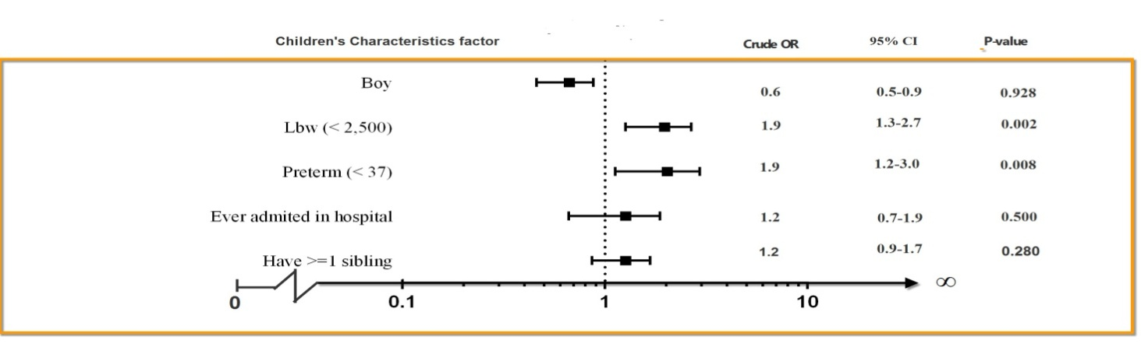

Fig. 2. Factors affecting on delayed cognitive development of all children’s characteristics presented as odds ratio adjusted for, gender, birth weight, gestational age, hospital admission, and number of sibling using logistic regressions

Factors effecting on Cognitive development of all caregiver’s characteristics
The strongest factor that effecting on delayed cognitive development of all types was age. That is, caregiver who younger was 1.6 times the risk of delayed cognitive development compared to who did not (95%CI: 1.2-2.2; p = 0.001)
(Fig.3).

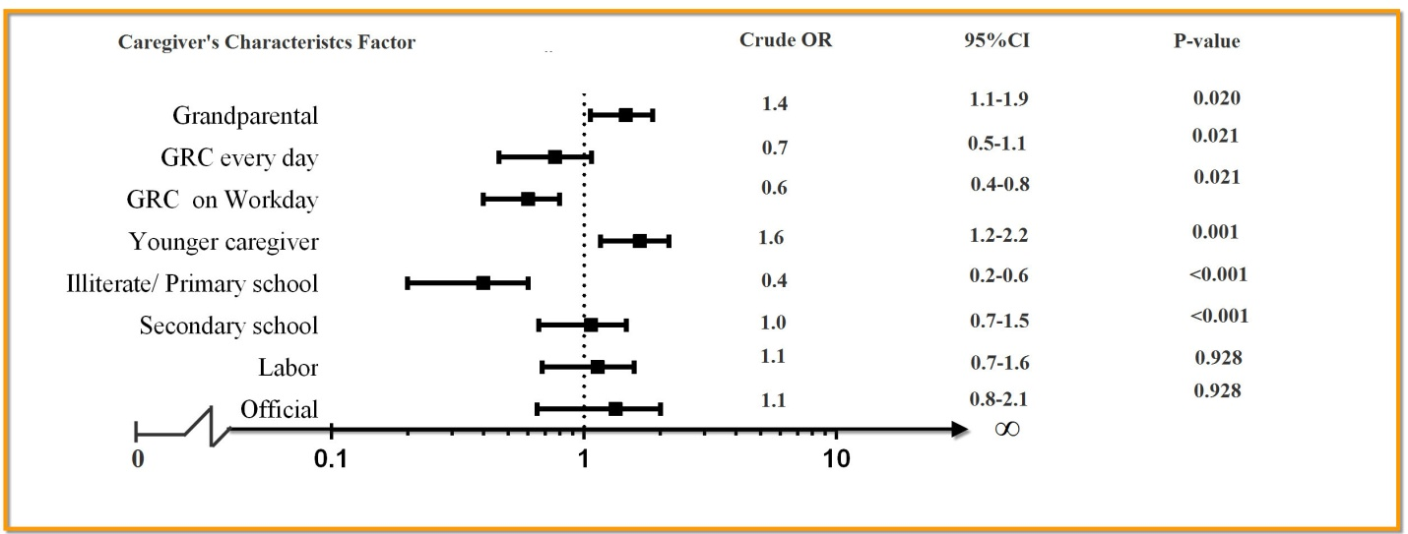

Fig.3. Factors affecting on delayed cognitive development of all caregiver’s characteristics presented as odds ratio adjusted for, primary caregiver, Child rearing duration of grandparents, age, education and occupation using logistic regressions

Factors effecting on Cognitive development of all dimensions of child rearing
The strongest factor affecting on delayed cognitive development of all types was Responsiveness dimensions of warmth. That is, item who less warmth was 3.7 times the risk of delayed cognitive development compared to who did not ( 95%CI: 1.5-9.0; p = 0.013)
(Fig.4).

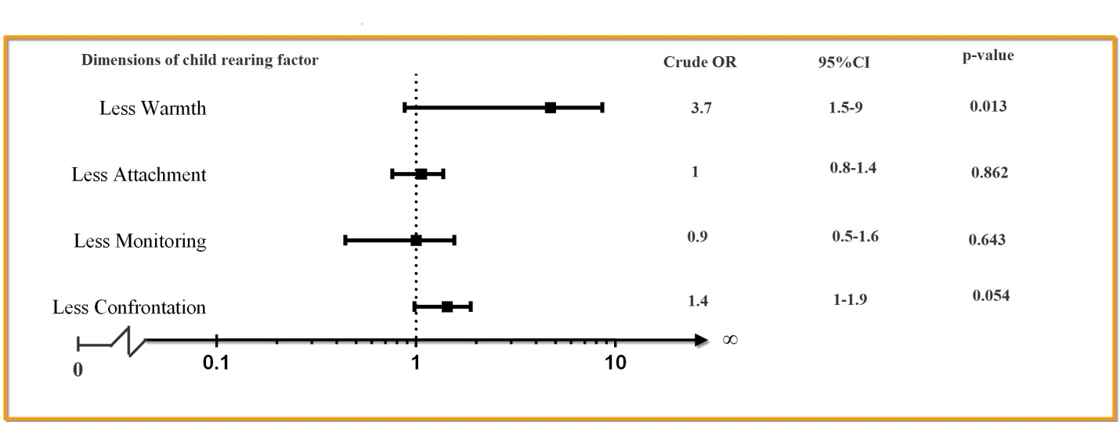

Fig.4. Factors effecting on delayed cognitive development of all dimensions of child rearing presented as odds ratio adjusted for, Responsiveness dimension: Warmth, Cohesion, Clear communication and Attachment. Demandingness dimension: Monitoring, Confrontation and Consistent- using logistic regressions

Factors effecting on children’s cognitive development adjusted for all other factors
Less warmth was predominantly the strongest factor effecting on cognitive development, was 5.0 times the risk of delayed cognitive development compared to who did not (95%CI: 1.9 –13.0; p < 0.001) (Fig. 5).
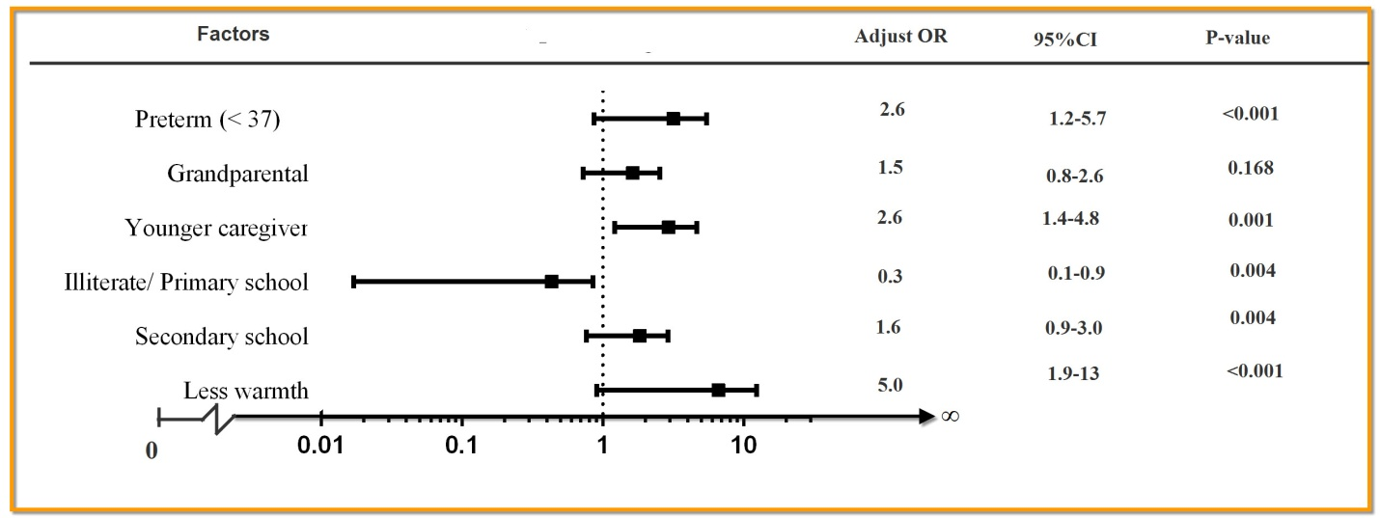
Fig. 3. Factors effecting on children’s cognitive development, presented as odds ratio adjusted for gestational age, primary caregiver, age of caregiver, education and Responsiveness dimensions of warmth, using stepwise logistic regression.

DISCUSSIONS

Thai society changed to modernization, parents of the child immigrate to work in the industrialized or urban areas. This meant that parents left their children behind with the grandparents as caregivers. The study found that children delayed of cognitive development were 182 (4.71% ).Using logistic regression analysis found that children who reared by grandparents had 1.4 times chance of being delayed cognitive development than those reared by parents.
Which was congruent with the studies by Nanthamongkolchai et.al,2006 (10) found that Children reared by a grandparent had 2.0 times higher chance of having delayed development compared with those who were reared by the parent which means that the parent had an important role in child rearing and promoting intellectual development of the children. Even though grandparents could rear and promote growth development and nutrition (9,13,14)of the children but lack the skills to promote learning processes and intellect-promoting activities for the children. While gathering analyzed with child, caregiver and dimensions of child rearing variants by stepwise logistic regression pointed out that the child reared by grandparent not significantly. That is because Child rearing is a process where a family or a parent or caregiver practices or interacting with children (33) It is a dynamic and has a bi-directional reflected back and forth (34), the children of each family is different, and treat a wide variety of children. So the factors that influence the complex processes associated with child rearing However, the present study showed that the child rearing and child development were statistically different among the children reared by grandparents
Factors influencing the development of the child reared by grandparents were birth weight, gestational age, age of caregiver, education and warmth .The study showed that low birth
weight in this study which infants weighing less than 2,500 grams effecting on cognitive development. Which was congruent with the studies by Oliveira et.al., 2011; Chaudhari et al., 2013; Walch et al.,2009 and Mu et.al., 2008.(35–38).But them used very low birth weight criteria for analysis. Preterm < 37 weeks was significant which was congruent with the studies by Lee and Barratt,1993 and Feldman and Eidelman,2006. The present study also found that caregiver’s characteristics had a significant impact on children’s cognitive development. Those children who were cared for by older caregivers were less likely to have delay cognitive development than those who were cared for by younger caregivers. This could be because younger caregivers tend to be busy with their work and lack sufficient time to provide adequate support and nurturance for children under their care(39).Low education caregiver was significant which was congruent with the studies by Nanthamongkolchai et.al,2009 (10) It was found that the children were reared by caregiver with higher education levels are more likely to have primary normal development than children who have been reared by with primary education or less than about 2.2 times. Education is one element that helps a person with knowledge and understanding of information. Have an understanding of child-rearing and adjustment to the role of caregiver. And warmth was not found direct studies of child rearing dimensions on children's cognitive development but have similar studies such as the study by Hindman and Morrison,2012 (26) found that parents teaching about letters and sounds was associated with alphabet knowledge, while shared book reading was marginally linked to vocabulary. Management/discipline was uniquely related to self regulation and Wong,2011(27) found that domineering control predicted more frequent demonstrations of child problem behaviors. In addition, parental behavior control, parental warmth and parental teaching variables together predicted the frequency of child's peer interaction and independence, but not cooperation. Furthermore, it was found that parental teaching behavior was a unique factor in predicting an increase in child social interaction and independence skills.

Strength of the study
The strengths of the study include: the wealth of prospective, longitudinal, epidemiological collected from observational, community-based study followed 4,245 infants from birth in
October 2000 to September 2002 until three years old. It is the evidence that was based on the largest cohort study of Thai children. Information of child development had been collected such as growth, social-emotional development, cognitive development and child rearing. This study utilized this component of the study. It can be viewed as the first project of evidence for Thai children in this area. This study utilized this component of the study. It can be viewed as the first piece of evidence for Thai children in this area. And this study deep investigated to dimensions of child rearing these make we know which items and activity should be caregiver strongest done to promote children’s cognitive development.

Limitation of the study
Limitations should be recognized. Confounding bias from other factors such as experience of child rearing, health status and substance abuse.

Conclusions
Child rearing by grandparents was at substantial risk for delay of cognitive development when combined with other factors to promote.While warmth was strongest factor effecting. To alleviate the problem, high attention should be emphasized caregiver to hug or kiss, compliment and happy smiling or clapping with children and realized age and education of caregiver. In addition should be healthy pregnant women to prevent miscarriage.

Recommendations
Health officials in the area should encourage the integration of caregiver. The opportunity to exchange experience and knowledge of child rearing.Specific knowledge and skills that are not appropriate dimension Focus on the children warmth ;emphasized caregiver to hug or kiss, compliment and happy smiling or clapping with children and the skill in fostering learning processes and intellect-promoting activities for the children . State and relevant agencies should propose a policy in promoting the cognitive development of children since was subjected in the womb maternal and should systematically and continuously intervention in the family have children cognitive developmental delayed. In addition should be qualitative study to investigate the child rearing into a culture.
Acknowledgements:
The authors express their heartfelt gratitude to the families who participated in the study. The research was supported by the Thailand Research Fund, the Health System Research Institute, the Ministry of Public Health and the World Health Organization.

REFERRENCES

1. Luong QV. How Can Child Labor Lead to an Increase in Human Capital of Child Laborers and What Are Policy Implications? [Internet] [Ph.D.]. [United States -- California]: University of California, Berkeley; 2011 [cited 2013 Jul 7]. Available from: http://search.proquest.com/docview/928449962/abstract/13F1F0FECEA44FB4053/13?accountid=27797
2. Bustelo M. Three essays on investments in children’s human capital [Internet] [Ph.D.]. [United States -- Illinois]: University of Illinois at Urbana-Champaign; 2011 [cited 2013 Jul 7]. Available from: http://search.proquest.com/docview/1009735727/abstract/13F1F0FECEA44FB4053/19?accountid=27797
3. Singer HS, Chiu AY, Meiri KF, Morell P, Nelson PG, Tennekoon G. Advances in understanding the development of the nervous system. Curr Opin Neurol. 1994;7(2):153–9.
4. Rush EC, Paterson J, Obolonkin VV, Puniani K. Application of the 2006 WHO growth standard from birth to 4 years to Pacific Island children. Int J Obes. 2008 Mar;32(3):567–72.
5. Childhood and adolescence; voyages in development, 2d ed. (CD-ROMs and workbook included). Ref Res Book News. 2005 Aug;20(3):n/a.
6. Stein MT. Rapid Brain Growth in Infants with Autism. J Watch Pediatr Adolesc Med [Internet]. 2003 Aug 11 [cited 2013 Jul 7]; Available from: http://search.proquest.com/docview/1284498764/13F1F4BA2582D99A16E/8?accountid=27797
7. De Onis M, Onyango A, Borghi E, Siyam A, Blössner M, Lutter C. Worldwide implementation of the WHO Child Growth Standards. Public Health Nutr. 2012 Sep;15(9):1603–10.
8. Adhikari R, Jampaklay A, Chamratrithirong A, Richter K, Pattaravanich U, Vapattanawong P. The Impact of Parental Migration on the Mental Health of Children Left Behind. J Immigr Minor Heal Cent Minor Public Heal. 2013 Apr 2;
9. Nanthamongkolchai S, Munsawaengsub C, Nanthamongkolchai C. Comparison of the health status of children aged between 6 and 12 years reared by grandparents and parents. Asia-Pac J Public Heal Asia-Pac Acad Consort Public Heal. 2011 Sep;23(5):766–73.
10. Nanthamongkolchai S, Munsawaengsub C, Nanthamongkolchai C. Influence of child rearing by grandparent on the development of children aged six to twelve years. J Med Assoc Thail Chotmaihet Thangphaet. 2009 Mar;92(3):430–4.
11. Gullette GS. The Role of Urbanity, Status, and Identity on Migrant Remittance Management and Rural Development Potentials in Thailand. Hum Organ. 2013 Summer;72(2):132–43.
12. Garip F, Curran S. Increasing Migration, Diverging Communities: Changing Character of Migrant Streams in Rural Thailand. Popul Res Policy Rev. 2010 Oct;29(5):659–85.
13. Onyango A, Tucker K, Eisemon T. Household headship and child nutrition: A case study in Western Kenya. Soc Sci Med. 1994;39(12):1633–9.
14. Graziano B, Cecilia G. CONACO M. The Impact of Labour Migration on the Children Left Behind: A Study of Elementary School Children in the Philippines.
15. Cheung CS, McBride-Chang C. Relations of Perceived Maternal Parenting Style, Practices, and Learning Motivation to Academic Competence in Chinese Children. Merrill-Palmer Q. 2008;54(1):1–22.
16. Lindhout IE, Markus MT, Hoogendijk TH, G M, Boer F. Temperament and parental child-rearing style: unique contributions to clinical anxiety disorders in childhood. Eur Child Adolesc Psychiatry. 2009 Jul;18(7):439–46.
17. Baker CN, Hoerger M. Parental Child-Rearing Strategies Influence Self-Regulation, Socio-Emotional Adjustment, and Psychopathology in Early Adulthood: Evidence from a Retrospective Cohort Study. Pers Individ Differ. 2012 May 1;52(7):800–5.
18. Frenn M, Pruszynski JE, Felzer H, Zhang J. Authoritative feeding behaviors to reduce child BMI through online interventions. J Spec Pediatr Nurs. 2013;18(1):65–77.
19. Chao RK. Beyond Parental Control and Authoritarian Parenting Style: Understanding Chinese Parenting through the Cultural Notion of Training. Child Dev. 1994;65(4):1111–9.
20. R. Murray G, Mulvaney MK. Parenting Styles, Socialization, and the Transmission of Political Ideology and Partisanship. Polit Policy. 2012;40(6):1106–30.
21. Lee G, McCreary L, Kim MJ, Park CG, Yang S. Individual and environmental factors influencing questionable development among low-income children: differential impact during infancy versus early childhood. J Korean Acad Nurs. 2012 Dec;42(7):1039–49.
22. Balaguru S. Acculturation and its impact on child rearing and child behavioral problems: A study of Asian-Indian immigrant families [Internet] [Ph.D.]. [United States -- Virginia]: University of Virginia; 2004 [cited 2013 Jul 5]. Available from: http://search.proquest.com/docview/305106744/abstract/13F12A11F52A428C44/1?accountid=27797
23. Velasco CT. A study of the attitudes, beliefs, and self-reported practices of Mexican immigrant mothers about child rearing [Internet] [M.S.W.]. [United States -- California]: California State University, Long Beach; 2008 [cited 2013 Jun 18]. Available from: http://search.proquest.com/docview/304840576/abstract/13EBAFD15AD2965FE9D/5?accountid=27797
24. Sands RG, Goldberg-Glen RS. Factors associated with stress among grandparents raising their grandchildren. Fam Relations. 2000 Jan;49(1):97–105.
25. Averett SL, Gennetian LA, Peters HE. Paternal child care and children’s development. J Popul Econ. 2005 Sep;18(3):391–414.
26. Hindman AH, Morrison FJ. Differential Contributions of Three Parenting Dimensions to Preschool Literacy and Social Skills in a Middle-Income Sample. Merrill-Palmer Q. 2012;58(2):191–223.
27. Wong MKW. Parental Teaching, Warmth, and Control as Predictors of Child Social Competence in Immigrant Chinese Families [Internet] [Ph.D.]. [United States -- California]: Alliant International University, San Francisco Bay; 2011 [cited 2013 Jul 7]. Available from: http://search.proquest.com/docview/884230126/abstract/13F1FB57E0461D99911/2?accountid=27797
28. Chen X, Liu M, Li D. Parental warmth, control, and indulgence and their relations to adjustment in Chinese children: a longitudinal study. J Fam Psychol JFP J Div Fam Psychol Am Psychol Assoc Div 43. 2000;14(3):401–19.
29. Munsell KL. A screening battery for identifying at-risk infants: Prediction of outcome on Bayley Scales of Infant/Todder Development-III [Internet] [Ph.D.]. [United States -- California]: Alliant International University, Fresno; 2006 [cited 2013 Jul 8]. Available from: http://search.proquest.com/docview/304912023/abstract/13F22632B18261FA0B6/5?accountid=27797
30. Voigt RG, Brown FR, Fraley JK, Llorente AM, al et. Concurrent and Predictive Validity of the Cognitive Adaptive Test/Clinical Linguistic and Auditory Milestone Scale (CAT/CLAMS) and the Mental Developmental Index of the Bayley Scales of Infant Development. Clin Pediatr (Phila). 2003 Jun;42(5):427–32.
31. Pittock ST, Juhn YJ, Adegbenro A, Voigt RG. Ease of administration of the cognitive adaptive test/clinical liguistic and auditory milestone scale (CAT/CLAMS) during pediatric well-child visits. Clin Pediatr (Phila). 2002 Aug;41(6):397–403.
32. Harris SR, Megens AM, Backman CL, Hayes VE. Stability of the Bayley II Scales of Infant Development in a sample of low-risk and high-risk infants. Dev Med Child Neurol. 2005 Dec;47(12):820–3.
33. Brooks J. The process of parenting. 6th ed. New York: McGraw-Hill; 2004.
34. Berns RM. Child, family, community: socialization and support. 3rd ed. Fort Worth: Harcourt Brace College Pub;
35. Oliveira GE, Magalhães LC, Salmela LFT. Relationship between very low birth weight, environmental factors, and motor and cognitive development of children of 5 and 6 years old. Rev Bras Fisioter São Carlos São Paulo Braz. 2011 Apr;15(2):138–45.
36. Chaudhari S, Otiv M, Khairnar B, Pandit A, Hoge M, Sayyad M. Pune Low Birth Weight Study - Birth to Adulthood - Cognitive Development. Indian Pediatr. 2013 Apr 5;
37. Walch E, Chaudhary T, Herold B, Obladen M. Parental bilingualism is associated with slower cognitive development in very low birth weight infants. Early Hum Dev. 2009 Jul;85(7):449–54.
38. Mu S-C, Tsou K-S, Hsu C-H, Fang L-J, Jeng S-F, Chang C-H, et al. Cognitive development at age 8 years in very low birth weight children in Taiwan. J Formos Med Assoc Taiwan Yi Zhi. 2008 Dec;107(12):915–20.
39. Fan F, Sang B. Absence of parental upbringing and Liushou children’s personality, academic achievements as well as behavior problems. Psychol Sci. 2005;28(156):855–9.

