TITLE PAGE

Title: Association between Systolic Blood Pressure and Congestive Heart Failure Complication among Hypertensive Patients With and Without Coexisting Diabetes in Thai Population

Authors: Sutheera Intajarurnsan¹, Bandit Thinkamrop² , <Others to be added>
Affiliations:
¹ Doctor of Public Health Student, Faculty of Public Health, Khon Kaen University, Thailand

² Department of Biostatistics and Demography, Faculty of Public Health, Khon Kaen University, Thailand

Corresponding authors:

Name: Bandit Thinkhamrop
Address: Department of Biostatistics and Demography, Faculty of Public Health, Khon Kaen University, Khon Kaen, 40002, Thailand
Telephone: +66-85-0011123
Fax: +66-43-362075
e-Mail: bandit@kku.ac.th

Type of contribution: Original research results

Running title: Association between Systolic Blood Pressure and Congestive Heart Failure Complication among Hypertensive Patients With and Without Coexisting Diabetes

Number of words in the abstract: 358

Number of words in the text: 3,218

Number of tables: 2

Number of figures: 3
ABSTRACT

Background: Of all the potential complications of hypertension (HT), congestive heart failure (CHF) is most consistently found. Moreover, people also suffering from type II diabetes (DM) tend to have two to four times greater risk of CHF. However, there are some controversial findings regarding the association between systolic blood pressure (SBP) and risk of CHF, and not all observational studies have indicated that lower SBP levels, are linked to lower cardiovascular event rate. In addition, the existing role of diabetes remains unclear.

Objective: To determine the association between systolic blood pressure and congestive heart failure among hypertensive patients and examine the level of association in patients with and without coexisting diabetes.

Methods: This cross-sectional study is a part of the survey “An Assessment on Quality of Care among Patients Diagnosed with Type 2 Diabetes and Hypertension Visiting Hospitals of Ministry of Public Health and Bangkok Metropolitan Administration in Thailand”, conducted from 2010 to 2012 involving 174,578 nationally representative samples of DM and HT patients. Data were collected from medical records. This paper concerned 150,312 of hypertensive (HT) and diabetic hypertensive (DMHT) patients who underwent screening. Multiple logistic regression was used for data analysis.

Results: After controlling for covariates, factors associated with coexistence of hypertension and diabetes included; gender, age, body mass index, fasting plasma glucose, occupation, and smoking history. This study found that there was no significant association between SBP and CHF among HT alone patients, although those with high systolic blood pressure levels, were more likely to suffer CHF. On the other hand, a significant association was found among DMHT patients with SBP ≥ 160 mmHg (OR = 1.52; 95%CI: 1.04 to 2.23; p = 0.030). However, it might be interpreted as inconclusive finding when inferring in population due to the precision of 95%CI. Moreover, age at least 60, obese, and smoking were significant factors in both HT (only) and DMHT groups.

Conclusions: SBP was not significantly associated with CHF among HT (only) patients overall, additional coexisting diabetes in those with very high blood pressure showed tendency of increasing risk. However, this study presented inconclusive finding.

Key words: systolic blood pressure, congestive heart failure, hypertension, diabetes
INTRODUCTION

As many as 1 billion people worldwide suffer from hypertension, which is estimated to cause 4.5% of current global burden disease, particularly in developing countries^{1,2}. In Thailand, burden of diseases defined as total disability-adjusted life year (DALY) loss attributed to hypertension was 5.5% each in both men and women³. Of all potential complications of hypertension, cardiovascular diseases (CVD) including congestive heart failure (CHF), were consistently found⁴. They are leading causes of premature death and disability^{5,6}. In addition, hypertension affects up to 60% of people with diabetes and substantially increases the risk of cardiovascular events^{7,24}. Elevated blood pressure (BP), especially systolic blood pressure (SBP), is an important risk factor for CHF among individuals with diabetes^{7,8,23,24,25}. As increasing age, systolic blood pressure gradually rises, particularly from 60 years of age^{9,10,24}. Most observational studies suggested that lower SBP, achieved the lower CHF event rate^{2,4,8}. On the other hand, not all observational studies have indicated in the same direction^{11,12,13}. There are some controversial findings and not much epidemiologic evidence regarding association between SBP and risk of CHF. In addition, the existing role of diabetes remains unclear in Thai population. This study aimed to determine the association between SBP and CHF among hypertensive patients and examine the level of association in patients with and without coexisting diabetes.

MATERIALS AND METHODS

Study design
This cross-sectional study is a part of the survey of An Assessment on Quality of Care among Patients Diagnosed with Type 2 Diabetes and Hypertension Visiting Hospitals of Ministry of Public Health and Bangkok Metropolitan Administration in Thailand, conducted from 2010 to 2012. A total of 6,277,543 DM and HT patients registered at hospitals of Ministry of Public Health. Nationally representative samples of 174,578 patients with diabetes and/or hypertension were randomly selected which based on the probability proportional to size of the patients from 602 hospitals across Thailand. Data was collected from medical records. This paper included total 150,312 sample of HT and DMHT patients, divided into 95,035 HT and 55,277 DMHT patients, who underwent screening. Multiple logistic regression was used for data analysis.

Study outcome
This study mainly focused on association between SBP and CHF complication and also examine the level of association in patients with and without coexisting diabetes. According to the Joint National Committee on Prevention, Detection, Evaluation, and Treatment of High Blood Pressure (JNC) issued its seventh report with guidelines for treatment¹. There are consisted with normal; SBP < 120 mmHg, pre-hypertension; SBP 120-139 mmHg, hypertension stage I; SBP 140-159 mmHg, hypertension stage II : SBP ≥160 mmHg. Furthermore, CHF complication assessment (yes/no) was diagnosed by physicians.

Statistical analysis
- Methods for describing baseline characteristics of the sample: Demographic characteristics of the participants were described using frequency and percentage which calculated by using descriptive statistic analysis.
- Methods for answering the research question(s): The association between SBP and CHF was calculated by using multiple logistic regression. Probability proportional to size of the patients from each hospital was used to account for the sampling design of the study. This method was also investigated factors that affect CHF complication, odds ratios (ORs) and their 95% confidence intervals (95%CIs) were estimated for cross-sectional sampling. This analysis was adjusted for baseline variables that were considered biologically and sociologically relevant with outcomes such as gender, age, occupation, smoking history, body mass index (BMI), diastolic blood pressure (DBP), and fasting plasma glucose.
- Software, level of significant, and ethics (with trial registration ID number, if being registered at http://www.clinicaltrials.in.th): All analyses were performed using Stata version 12.0 (Stata Corp, College Station, TX). All test statistics were two-sided and a p-value of less than 0.05 was considered statistical significant. This project was approved by the Human Research and Ethics Committees of the Ministry of Public Health of Thailand.

RESULTS
A total of 6,277,543 DM and HT patients registered at hospitals of Ministry of Public Health, since 2010-2012. Nationally representative samples of 174,578 patients with diabetes and/or hypertension were randomly selected from 602 hospitals across Thailand. The samples were selected based on the probability proportional to size of the patients for each hospital. Samples of 150,312 patients with HT (only) and DMHT were included in this study, after exclusion of DM (only) patients, responded to the survey, and agreed to participate as members of the DM/HT data based (Fig. 1).

Population of DM/HT patients registered Hospitals of Ministry of Public Health
Since 2010-2012
(N = 6,277,543)

Total sample of DM/HT patients
Since 2010-2012
(n = 174,578)

Exclude 24,266 of DM (only)

Sample of HT (only) and DMHT patients
(n = 150,312)

Study participants (n = 150,312)
95,035 for HT (only)
55,277 for DMHT

Fig. 1. The inclusion flow chart
Demographic Characteristics

Of the 150,312 HT and DMHT patients, almost all of them, 65.4% were female with 59.1% were at least 60 years old (Table 1). Mostly had non-sedentary occupations (57.5%), and were classified as non-obese (52.3%).

Table 1. Demographic characteristics presented as percentage unless specified otherwise
Characteristics | Total  (n = 150,312) |  | HT (only)  (n = 95,035 ) |  | DMHT  (n = 55,277)
Characteristics | No. | % | No. | % | No. | %
Gender
Male | 52,037 | 34.6 | 35,138 | 37.0 | 16,899 | 30.6
Female | 98,262 | 65.4 | 59,889 | 63.0 | 38,373 | 69.4
Total | 150,299 | 100.0 | 95,027 | 100.0 | 55,272 | 100.0
Age (years)
< 60 | 61,477 | 40.9 | 37,891 | 39.9 | 23,586 | 42.7
≥ 60 | 88,759 | 59.1 | 57,084 | 60.1 | 31,675 | 57.3
Mean (SD) | 62.30 (11.14) |  | 62.77 (11.57) |  | 61.48 (10.29)
Median (Min:Max) | 62 (20:107) |  | 63 (20:107) |  | 61 (20:98)
Total | 150,236 | 100.0 | 94,975 | 100.0 | 55,261 | 100.0
Occupation
Non-sedentary | 82,940 | 57.5 | 52,843 | 57.8 | 30,097 | 57.0
Sedentary | 61,340 | 42.5 | 38,645 | 42.2 | 22,695 | 43.0
Total | 144,280 | 100.0 | 91,488 | 100.0 | 52,792 | 100.0
Smoking History
No | 31,860 | 40.9 | 19,276 | 40.3 | 40,889 | 90.2
Yes | 46,009 | 59.1 | 28,517 | 59.7 | 4,465 | 9.8
Total | 77,869 | 100.0 | 47,793 | 100.0 | 45,354 | 100.0
Body Mass Index;
BMI (kg/m²)
< 25.0 (Non-obese) | 70,303 | 52.3 | 46,905 | 55.7 | 23,398 | 46.5
≥ 25.0 (Obese) | 64,211 | 47.7 | 37,248 | 44.3 | 26,963 | 53.5
Total | 134,514 | 100.0 | 84,153 | 100.0 | 50,361 | 100.0
Systolic Blood Pressure;
SBP (mmHg)
< 140 | 103,050 | 68.9 | 65,850 | 69.6 | 37,200 | 67.6
140-159 | 38,057 | 25.4 | 23,778 | 25.1 | 14,279 | 26.0
≥ 160 | 8,538 | 5.7 | 5,022 | 5.3 | 3,516 | 6.4
Total | 149,645 | 100.0 | 94,650 | 100.0 | 54,995 | 100.0
Diastolic Blood Pressure;
DBP (mmHg)
< 90 | 129,618 | 86.7 | 81,263 | 85.9 | 48,355 | 88.1
90-99 | 16,938 | 11.3 | 11,305 | 12.0 | 5,633 | 10.3
≥ 100 | 2,908 | 2.0 | 2,014 | 2.1 | 894 | 1.6
Total | 149,464 | 100.0 | 94,582 | 100.0 | 54,882 | 100.0
Fasting Plasma Glucose;
FPG (mg/dl)
< 126 mg/dl | 54,149 | 36.0 | 42,045 | 44.2 | 18,131 | 32.8
≥ 126 mg/dl | 96,163 | 64.0 | 52,990 | 55.8 | 37,146 | 67.2
Total | 150,312 | 100.0 | 95,035 | 100.0 | 55,277 | 100.0

Percentages of CHF complication among hypertensive and diabetic hypertensive patients
Percentages of CHF complications among HT (only) and DMHT patients were likely observed in age at least 60 years was responsible for 4.9% and 17.1%, respectively (Table 2). In addition, most of them were obese (BMI ≥ 25.0) and had smoking history. Considering on SBP levels, this study showed that many of them had SBP level at least 160 mmHg for 4.7% and 22.6%, respectively.

Table 2. Unadjusted odds ratios (ORs) of CHF complication among HT (only) and DMHT patients with their 95% confidence intervals for each factor
Factors | HT (only) |  |  |  | DMHT
Factors | No. (%CHF) | OR | 95%CI | p-value | No. (%CHF) | OR | 95%CI | p-value
SBP (mmHg) |  |  |  | 0.014 |  |  |  | <0.001
< 140 | 915(3.5) | 1 |  |  | 406(12.1) | 1
140-159 | 374(3.8) | 1.07 | 0.95, 1.21 |  | 164(13.8) | 1.17 | 0.96, 1.42
≥ 160 | 113(4.7) | 1.35 | 1.11, 1.65 |  | 64(22.6) | 2.13 | 1.58, 2.87
DBP (mmHg) |  |  |  | 0.087 |  |  |  | 0.193
< 90 | 1,203(3.7) | 1 |  |  | 555(12.9) | 1
90-99 | 155(3.2) | 0.87 | 0.73, 1.03 |  | 67(16.1) | 1.30 | 0.98, 1.71
≥ 100 | 45(4.6) | 1.24 | 0.91, 1.68 |  | 8(12.5) | 0.97 | 0.46, 2.04
Gender |  |  |  | 0.125 |  |  |  | 0.260
Male | 541(3.9) | 1 |  |  | 205(14.1) | 1
Female | 864(3.5) | 0.92 | 0.82, 1.02 |  | 436(12.9) | 0.90 | 0.75, 1.08
Age (years) |  |  |  | <0.001 |  |  |  | <0.001
< 60 | 270(1.8) | 1 |  |  | 154(7.8) | 1
≥ 60 | 1,134(4.9) | 2.85 | 2.49, 3.26 |  | 488(17.1) | 2.45 | 2.02, 2.96
Occupation |  |  |  | <0.001 |  |  |  | <0.001
Non-sedentary | 628(3.0) | 1 |  |  | 298(10.6) | 1
Sedentary | 697(4.2) | 1.40 | 1.25, 1.56 |  | 303(16.4) | 1.66 | 1.40, 1.97
Smoking |  |  |  | <0.001 |  |  |  | 0.001
No | 254(1.4) | 1 |  |  | 452(11.7) | 1
Yes | 448(15.6) | 12.76 | 10.88, 14.97 |  | 72(17.6) | 1.60 | 1.22, 2.10
BMI (kg/m²) |  |  |  | 0.048 |  |  |  | 0.004
< 25.0 | 645(3.5) | 1 |  |  | 238(11.1) | 1
≥ 25.0 | 558(3.9) | 1.12 | 1.00, 1.26 |  | 337(13.9) | 1.29 | 1.08, 1.54
FPG (mg/dl) |  |  |  | <0.001 |  |  |  | 0.287
< 126 | 579 (3.1) | 1 |  |  | 230(14) | 1
≥ 126 | 826(4.1) | 1.32 | 1.19, 1.47 |  | 412(12.9) | 0.91 | 0.76, 1.08

Factors associated with CHF complication among hypertensive (only) patients

Factors that significantly associated with CHF complication among HT (only) patients were gender, age, smoking, BMI, and FPG (Figure 2). In additions, there was no significant association between SBP and CHF complication among HT (only) patients, although those with high systolic blood pressure levels, were more likely to suffer CHF.

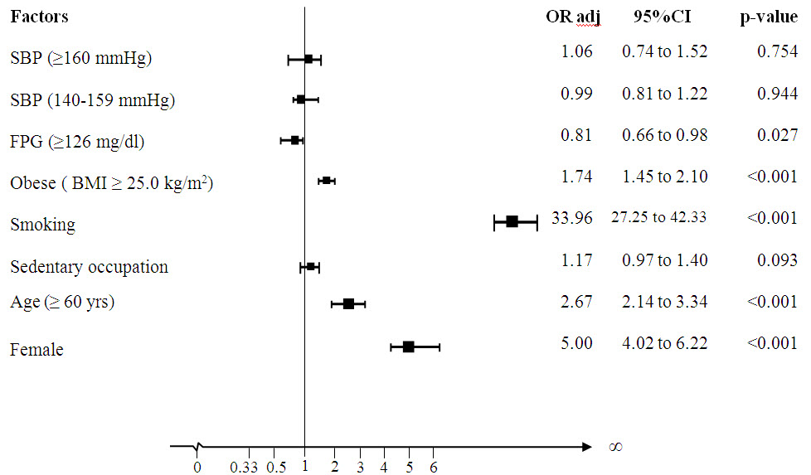

Fig. 2. Factors affecting CHF complication in HT (only) patients, presented as odds ratio adjusted for gender, age, occupation, smoking, BMI, and FPG, using multiple logistic regression

Factors associated with CHF complication in diabetic hypertensive (DMHT) patients

Factors that significantly associated with CHF complication among DMHT patients were gender, age, smoking, and BMI (Figure 3). Furthermore, there was significant association between SBP and CHF complication among DMHT patients with SBP ≥ 160 mmHg (OR = 1.52; 95%CI: 1.04 to 2.23; p = 0.030). However, it might be interpreted as inconclusive finding due to the precision of 95% confident interval.

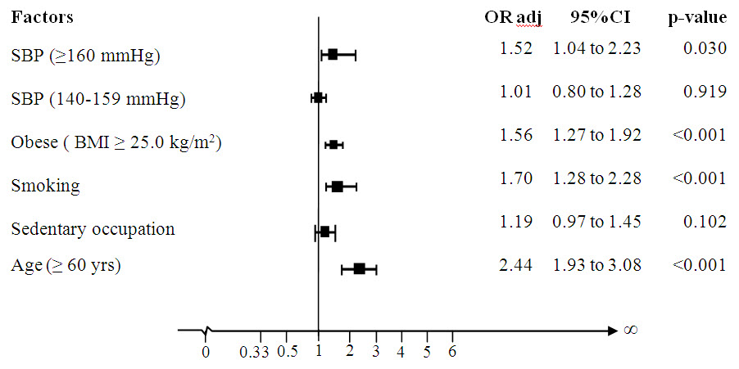

Fig. 3. Factors affecting CHF complication in DMHT patients, presented as odds ratio adjusted for age, occupation, smoking, and BMI, using multiple logistic regression

DISCUSSIONS

Explaining the findings

This study found that there was no significant association between SBP and CHF complication among HT (only) patients after adjusted for covariates; such as gender, age, occupation, smoking, BMI, and FPG. Although, those with high systolic blood pressure levels, were more likely to suffer CHF. On the other hand, there was significant association between SBP and CHF complication among DMHT patients, obviously who had SBP ≥ 160 mmHg (OR = 1.52; 95%CI: 1.04 to 2.23; p=0.030) when compared to those who had SBP < 140 mmHg. However, it might be interpreted as inconclusive finding when inferring in population due to the precision of 95% confident interval. Considering on the lower limit is 1.04 which closes to 1.00 (not different odd ratios). Therefore, association between SBP and CHF complication among DMHT patients remains inconclusive. Moreover, age at least 60, obese, and smoking were significant factors in both HT (only) and DMHT groups.
This observed association between SBP and CHF, among hypertensive patients with and without coexisting diabetes, was not consistent with other studies^{18,19,20}. The previous study, the UK Prospective Diabetes Study (UKPDS) was one of the first studies to find significant improvement in both macrovascular and microvascular disease risk in participants whose mean blood pressure was reduced to less than or equal to 144 mmHg. In the UKPDS, each 10 mmHg decrease in mean systolic blood pressure was associated with a 12% reduction in risk for all complications related to diabetes and an 11% reduction of risk of CVD such as myocardial infarction¹⁹. With increasing age, there was a gradual shift from DBP to SBP as predictors of CVD risk^{21,22}.
However, the present study had some limitations such as the large of missing data from medical records. This might affect level of association although handle with missing by using best case and worst case scenarios. Another limitation, the cross-sectional design might preclude drawing conclusion about cause effect relationship between risk factors and the outcome.

Strength of the study
- Nationally representative sample size
- Real situations
- Saving for time and budget
- Cross-sectional surveys can be used for the baseline data for the future follow-up study

Limitation of the study
- Insufficient data and missing values in medical records (secondary data)
- Information bias could occur from data recording by medical staffs
- Recall bias from self-directed questionnaire by patients

Conclusions
After controlling for covariates, SBP was not significantly associated with CHF among hypertensive (only) patients overall, additional coexisting diabetes in those with very high blood pressure showed tendency of increasing risk. However, this study presented inconclusive finding.

Recommendations
- Further understanding of those factors that predispose patients to congestive heart failure is essential to guide prevention strategies.
- Health care system should be designed to strengthen comprehensive health care of coexistence of hypertension and diabetes in order to decrease complications.

Acknowledgements: This material is based upon the survey of An Assessment on Quality of Care among Patients Diagnosed with Type 2 Diabetes (DM) and Hypertension (HT) Visiting Hospitals of Ministry of Public Health and Bangkok Metropolitan Administration in Thailand, conducted from 2010 to 2012. The authors thank to collaborative staffs with investigators of the Thailand DMHT study. A collaborative clinical study supported by the Thailand National Health Security Office (NHSO) and the Thailand Medical Research Network (MedResNet). The data was archived at the web site http://www.damus.in.th maintained by MedResNet.

REFERENCES

1. Jeffery L. Martin, M.D., F.A.S.N. Hypertension Guidelines: Revisiting the JNC 7 Recommendations. the Journal of Lancaster General Hospital. 2008. 3(3):91-97.
2. World Health Organization, International Society of Hypertension. 2003 World Health Organization (WHO) / International Society of Hypertension (ISH) statement on management of hypertension. 2003;21(11):1983-1991
3. Ministry of Public Health, Thailand Health Profile 2005-2006, Bureau of Policy and strategy, Ministry of Public Health, Nonthaburi, Thailand, 2007.
4. Haralambos G. Hypertension and congestive heart failure: Benefits of converting enzyme inhibition. 1983:1(2):518-520
5. Hisatomi Arima, Yoshitaka Murakami, Tai Hing Lam, et al. Effects of Prehypertension and Hypertension Subtype on Cardiovascular Disease in the Asia-Pacific Region. Journal of Hypertension. 2012;59:1118-1123
6. World Health Organization. The Atlas of Heart Disease and Stroke. Geneva, Switzerland: World Health Organization; 2004.
7. American Diabetes Association. Hypertension management in adults with diabetes. Diabetes Care. 2004;27(suppl 1):65-67
8. Stanley S. Systolic Blood Pressure—It’s time to take control. the American Journal of Hypertension. 2004;17:49-54
9. Franklin SS, Khan SA, Wong ND, Larson MG, Levy D. Is pulse pressure useful in predicting risk for coronary heart disease? The Framingham Heart Study. Circulation. 1999;100(4):354- 360.
10. Stanley S. Franklin, Martin G, et al. Does the Relation of Blood Pressure to Coronary Heart Disease Risk Change With Aging? : The Framingham Heart Study. American Heart Association. 2001;103:1245-1249.
11. Kathryn A, Michael J, and Luc Djousse. Normal systolic blood pressure and risk of heart failure in US male physicians. European Journal of Heart Failure. 2009;11:1129–1134
12. Raphael, C E, Whinnett Z I, Davies J E, et al. Quantifying the paradoxical effect of higher systolic blood pressure on mortality in chronic heart failure. 2009;95:56-62
13. Franklin St, William T, Nancy M, et al. Systolic Blood Pressure Predicts Mortality in Heart Failure Patients. University of California. 2006
14. Levy D, Larson MG, Vasan RS, Kannel WB, Ho KK. The progression from hypertension to congestive heart failure. JAMA 1996;275:1557–1562.
15. Haider AW, Larson MG, Franklin SS, Levy D. Systolic blood pressure, diastolic blood pressure, and pulse pressure as predictors of risk for congestive heart failure in the Framingham Heart Study. Ann Intern Med 2003;138:10–15.
16. Mainous AG, Everett CJ, Liszka J, King DE, Egan BM. Prehypertension and mortality in a nationally representative cohort. Am J Cardiol 2004;94:
1496–1500.
17: Cederholm J, Gudbjörnsdottir S, Eliasson B, Systolic blood pressure and risk of cardiovascular diseases in type 2 diabetes: an observational study from the Swedish national diabetes register. J Hypertens. 2010 Oct;28(10):2026-35.
18. Okayama A, et al. Impact of elevated blood pressure on mortality from all causes, cardiovascular
diseases, heart disease and stroke among Japanese: 14 year follow-up of randomly
selected population from Japanese. Journal of Human Hypertension. 2003;17:851–857
19. Jai Ganesh and Vijay Viswanathan. Tight blood pressure control and risk of macrovascular and microvascular complications in type 2 diabetes.: UKPDS 38. UK Prospective Diabetes Study Group. BMJ. 1998;317(7160):703-713.
20. American Diabetes Association. Hypertension management in adults with diabetes. Diabetes Care. 2004;27:65-67.
21. Stanley S. Franklin, MD; Martin G. Larson. Does the Relation of Blood Pressure to Coronary Heart Disease Risk Change With Aging? The Framingham Heart Study. Circulation. 2001;103:1245-1249.
22. Fisman EZ, Tenenbaum A. Cardiovascular Diabetology: Clinical, Metabolic and Inflammatory
Facets. Adv Cardiol. Basel, Karger. 2008;45:82–106.
23. Chen G, McAlister FA, Walker RL, et al. Cardiovascular outcomes in Framingham participants with diabetes: the importance of blood pressure. Hypertension. 2011;57:891–897.
24. Siriwat Tiptaradol1 and Wichai Aekplakorn. Prevalence, Awareness, Treatment and Control of Coexistence of Diabetes and Hypertension in Thai Population. International Journal of Hypertension. 2012
25. Marianne E. Gee, William Pickett, Ian Janssen, et al. Health Behaviors for Hypertension Management in People With and Without Coexisting Diabetes. Journal of Clinical Hypertension. 2013;15:389–396.

