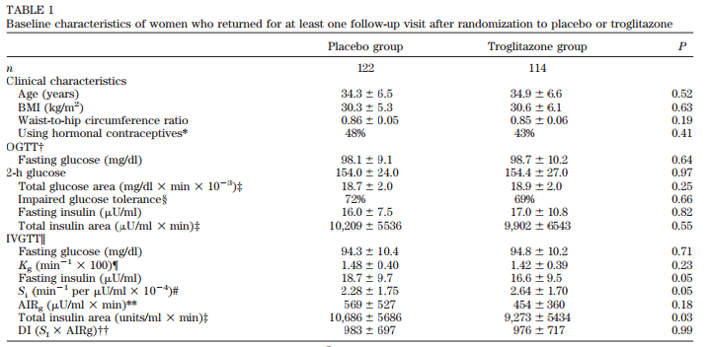

Table 1:
Baseline characteristics of women who returned for at least one follow-up visit after randomization to placebo or troglitazone
 | Placebo group |  | Troglitazone group |  | P
n |  | 122 |  | 114
Clinical characteristics
Age (years) | 34.3 | ± 6.5 | 34.9 | ± 6.6 | 0.52
BMI (kg/m²) | 30.3 | ± 5.3 | 30.6 | ± 6.1 | 0.63
Waist – to- hip circumference ratio | 0.86 | ± 0.05 | 0.85 | ± 0.06 | 0.19
Using hormonal contraceptives* | 48% |  | 43%
OGTT†
Fasting glucose (mg/dl) | 98.1 | ± 9.1 | 98.7 | ± 10.2 | 0.64
2-h glucose | 154.0 | ±24.0 | 154.4 | ± 27.0 | 0.97
Total glucose area (mg/dl x min x 10⁻³) ‡ | 18.7 | ± 2.0 | 18.9 | ± 2.0 | 0.25
Impaired glucose tolerance§ | 72% |  | 69% |  | 0.66
Fasting insulin (µU/ml) | 16.0 | ± 7.5 | 17.0 | ± 10.8 | 0.82
Total insulin area (µU/ml x min) ‡ | 10,209 | ± 5536 | 9,902 | ± 6543 | 0.55
IVGTT
Fasting glucose (mg/dl) | 94.3 | ± 10.4 | 94.8 | ± 10.2 | 0.71
K_{g} (min⁻¹ x 100) ¶ | 1.48 | ± 0.40 | 94.8 | ± 10.2 | 0.71
Fasting insulin (µU/ml) | 18.7 | ± 9.7 | 16.6 | ± 9.5 | 0.05
S₁ (min⁻¹ per µU/ml x 10⁻⁴)# | 2.28 | ± 1.75 | 2.64 | ± 1.70 | 0.05
AIR_{g} (µU/ml x min)** | 569 | ± 527 | 454 | ± 360 | 0.18
Total insulin area (units/ml x min) ‡ | 10,686 | ± 5686 | 9,273 | ± 5434 | 0.03
DI (S₁ x AIRg)† | 983 | ± 697 | 976 | ± 717 | 0.99

