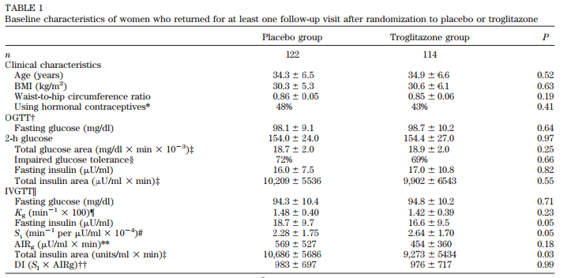

Table 1: Baseline characteristics of women
 | Placebo group | Troglitazone group | P
n | 122 | 114
Clinical characteristics
Age (years) | 34.3 ± 6.5 | 34.9 ± 6.6 | 0.52
BMI (kg/m²) | 30.3 ± 5.3 | 30.6 ± 6.1 | 0.63
Waist – to- hip circumference ratio | 0.86 ± 0.05 | 0.85 ± 0.06 | 0.19
Using hormonal contraceptives* | 48% | 43%
OGTT†
Fasting glucose (mg/dl) | 98.1 ± 9.1 | 98.7 ± 10.2 | 0.64
2-h glucose | 154.0 ±24.0 | 154.4 ± 27.0 | 0.97
Total glucose area (mg/dl x min x 10⁻³) ‡ | 18.7 ± 2.0 | 18.9 ± 2.0
Impaired glucose tolerance§
Fasting insulin (µU/ml)
Total insulin area (µU/ml x min) ‡
IVGTT
Fasting glucose
K
Fasting insuline
S
AIR
Total insulin area
DI

