TITLE PAGE

Title: The association between eGFR and Hyperosmolar Non-Ketotic Hyperglycemia Syndrome in Diabetes type 2

Authors: Jitjira Chaiyarit¹, Bandit Thinkamrop², Cameron P. Hurst³

Affiliations: Faculty of Public Health , Khon Kaen University, Khon Kaen, Thailand

Corresponding authors:
Name: Bandit Thinkhamrop
Address: Department of Biostatistics and Demography, Faculty of Public Health, Khon Kaen University, Khon Kaen, 40002, Thailand
Telephone: +66-85-0011123
Fax: +66-43-362075
e-Mail: bandit@kku.ac.th

Type of contribution: Original research results

Running title: The association between eGFR and Hyperosmolar Non-Ketotic Hyperglycemia Syndrome

Number of words in the abstract: 1,959

Number of words in the text:

Number of tables: 4

Number of figures: 2

ABSTRACT

Background: Hyperosmolar Non-Ketotic Hyperglycemia Syndrome (HNHS) is a life-threatening complication of uncontrolled diabetes mellitus and often found in patients with type 2 diabetes and have suggested of that older age, stopping insulin or other medications that lower glucose levels, poor management of diabetes and impaired thirst were risk factors of HNHS. The testing of kidney working is an uncommon complication of HNHS but probably subclinical and thus underestimated.

Methods: A analytic study was conducted. All information were collected from medical records of all patients diagnosed with diabetes type 2 during 2010-2012. The HNHS was the main outcome of this study. This paper included 24,266 who have been only diabetes type 2. To find the association of eGFR and the HNHS was analyzed using multiple logistic regression.

Results: There were 24,266 diabetes type 2. There were 2.40% (95%CI: 2.21 to 2.60) were HNHS. They were mainly female (71.17%). Almost all of them, 82.60%, were stage 1-2 of eGFR with a mean eGFR of 84.22 ± 24.44 mL/minute/1.73m² (ranged: 0.46: 400.23) and mean of age 56.09 ± 10.90 year-old (ranged: 20 - 98).The percentage for uncontrolled HbA1c patients was 71.07 and receiving ACEI or ARB 21.89. However, after adjusted for age and HbA1C were affected by stage of eGFR (adjusted OR_{2(vs1)} = 2.08; 95% CI: 1.65 to 2.61; p = <0.001, adjusted OR_{3(vs1)} = 2.55; 95% CI: 1.68 to 3.89; p = <0.001).

Conclusion: The study found statistically significant association between eGFR and HNHS. Therefore, the eGFR is one of factor that recognizing the early signs of dehydration can help prevent this condition.

Keywords: diabetes type 2, eGFR, HNHS, Acute complications

INTRODUCTION
Hyperosmolar Non-Ketotic Hyperglycemia Syndrome (HNHS) is a life-threatening complication of uncontrolled diabetes mellitus and often found in patients with type 2 diabetes, is a serious condition most frequently seen in older persons. [1,2]. In adults HNHS, mortality rate is about 15% [3]. Complications associated with HHNS include severe metabolic disturbances, renal impairment, and cardiovascular, thromboembolic, and neurological events [4]. The most recent papers indicated risk factors of HNHS are the elderly patients with non-insulin-dependent diabetes mellitus or other medications that lower glucose levels, poor management of diabetes and impaired thirst [2,5–7]. The testing of kidney working is an uncommon complication of HNHS but probably subclinical and thus underestimated. In this study, we investigated whether the association between eGFR and HNHS.

METHODS
Study participants
An analytic study was conducted. All information were collected from medical records of all patients diagnosed with diabetes type 2 during 2010-2012. The type of diabetic acute complications was based on medical records while HNHS was the main outcome of this study. The study subjects consisted of 24,038 who have been detected HNHS. Patients were excluded from participation in the study if either of the following
criteria applied: i) under age of 18, or ii) not been examined serum creatinine.

Data collection and clinical evaluation
This paper is part of the An Assessment on Quality of Care among Patients Diagnosed with Type 2 Diabetes and Hypertension visiting Hospitals in care of Ministry of Public Health and Bangkok Metropolitan Administration in Thailand, 2010-2012. The sampling method was stratified cluster sampling with probability proportional to size Hospitals in care of Ministry of Public Health and Bangkok Metropolitan Administration in Thailand.
Age (year), gender, serum creatinine (mg/dL), receiving ACEI or ARB and hemoglobin A1C (HbA1C) were ascertained from review of medical records. The estimated glomerular filtration rate (eGFR: mL/minute/1.73m²) was recalculated as age in year and serum creatinine in mg/dL by Chronic Kidney Disease Epidemiology Collaboration formula (CKD-EPI). The CKD-EPI formulas, expressed as two equations, are [8]:
For male:
For female:
Where sCr is serum creatinine (mg/dL).

Table 1. The Kidney Disease Outcomes Quality Initiative stages of kidney disease [9]

Stages of kidney disease | eGFR (mL/minute/1.73m²)
Stage 1 | ≥ 90
Stage 2 | 60-89
Stage 3 | 30-59
Stage 4 | 15-29
Stage 5 | < 15

Statistical analysis
For demographic characteristics all the continuous variables were presented as mean and standard deviation and all the categorical variables were presented as frequency and percentage. Logistic regression models were used to examine the statistical difference of proportions and estimate the odd ratios adjusted for eGFR and potential confounding factors.

Research frame
3,373,089 patients who visiting Hospitals in care
24,266 patients were only DM

150,312 were excluded

24,038 patients who have been detected HNHS

Missing of HNHS (228)
174,578 patients were randomized

Fig. 1. The screening flow chart

RESULTS
Baseline characteristics of the participants
Of the 24,133 DM patients, almost all of them, 82.60%, were stage 1-2 of eGFR with a mean eGFR of 84.22 ± 24.44 mL/minute/1.73m² (Table 1). They were mainly female (71.17%), with a mean age of 56.09 ± 10.90 year-old (ranged: 20 - 98) currently received ACEI or ARB (21.89%) and a mean HbA1C of 8.33 ± 2.14 % (ranged: 0.10 - 20.50)

Table 2. Baseline characteristics presented as number and percentage unless specified otherwise

Baseline characteristics | Number | Percent
eGFR (mL/minute/1.73m²)
Stage 1-2 | 19,933 | 82.60
Stage 3 | 3,477 | 14.41
Stage 4-5 | 723 | 3.00
Total | 24,133 | 100.00
Mean (SD) | 84.22 (24.44)
Median (Min: Max) | 91.22 (0.46: 400.23)
Gender
Male | 6,995 | 28.83
Female | 17,268 | 71.17
Total | 24,263 | 100.00
Age (years)
< 60 years | 15,246 | 62.88
≥ 60 years | 8,999 | 37.12
Total | 24,245 | 100.00
Mean ± standard deviation | 56.09 (10.90)
Median (Min:Max) | 56 (20 : 98)
Receiving ACEI or ARB
No | 14,968 | 78.11
Yes | 4,194 | 21.89
Total | 19,162
Baseline characteristics | Number | Percent
HbA1C
< 7% | 5,107 | 28.93
≥ 7% | 12,546 | 71.07
Total | 17,653 | 100.00
Mean ± standard deviation | 8.33 (2.14)
Median (Min:Max) | 7.90 (0.10 : 20.50)

Factors associated with HNHS
Univariate Analysis
The strongest factor that associated to HNHS of all types was eGFR. That is, the patients who had eGFR was stage 3 were 2.26 times the risk of the HNHS compared to who had eGFR was stage 1-2 (OR = 2.26; 95%CI: 1.87 to 2.74; p < 0.001) and the patients who had eGFR was stage 4-5 were 2.37 times the risk of the HNHS compared to who had eGFR was stage 1-2 (OR = 2.37; 95%CI: 1.65 to 3.41; p < 0.001) (Table 3). The second strongest factor was HbA1C (OR = 2.02; 95%CI: 1.55 to 2.64; p < 0.001). Others factors that were not significant factors, p>0.05.

Table 3. Crude Odds ratios (OR) and their 95% confidence intervals of having HNHS for each factor presented in the table using logistic regression

Variable | Total | % HNHS | Crude OR | 95%CI |  | p-value
eGFR |  |  |  |  |  | <0.001
Stage 1-2 | 19,933 | 1.98 | 1
Stage 3 | 3,477 | 4.37 | 2.26 | 1.87 | to 2.74
Stage 4-5 | 723 | 4.56 | 2.37 | 1.65 | to 3.41
Gender |  |  |  |  |  | 0.841
Male | 6,921 | 2.37 | 1
Female | 17,114 | 2.41 | 1.02 | 0.85 | to 1.22
Age |  |  |  |  |  | 0.721
< 60 years | 15,106 | 2.43 | 1
≥ 60 years | 8,911 | 2.36 | 0.97 | 0.82 | to 1.15
Variable | Total | % HNHS | Crude OR | 95%CI |  | p-value
Receiving ACEI or ARB |  |  |  |  |  | 0.787
No | 14,968 | 2.71 | 1
Yes | 4,194 | 2.79 | 1.03 | 0.84 | to 1.27
HbA1C |  |  |  |  |  | <0.001
< 7% | 5,106 | 1.29 | 1
≥ 7% | 12,546 | 2.58 | 2.02 | 1.55 | to 2.64

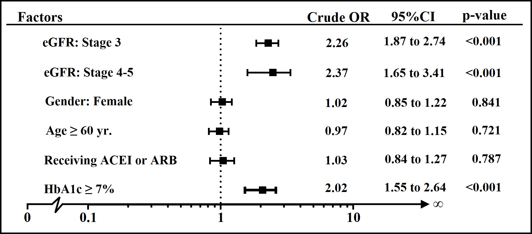

Fig. 1.

Multivariate Analysis
All the variables with a significant impact (p<0.20) in the univariate analysis (Table 3) were considered for the multivariate analysis. After adjusted for age and HbA1C in the Logistic regression model found that the patients who had eGFR was stage 3 were 2.27 times the risk of the HNHS compared to who had eGFR was stage 1-2 (OR = 2.27; 95%CI: 1.79 to 2.89; p < 0.001) and the patients who had eGFR was stage 4-5 were 2.89 times the risk of the HNHS compared to who had eGFR was stage 1-2 (OR = 2.89; 95%CI: 1.89 to 4.43; p < 0.001) (Table 4).

Table 4. Adjusted Odds Ratios (adj.OR) and their 95% confidence intervals of having HNHS for all other factors presented in the table using multiple logistic regression

Variable | Total | % HNHS | Crude OR | Adj. OR | 95%CI |  | p-value
eGFR |  |  |  |  |  |  | <0.001
Stage 1-2 | 19,933 | 1.98 | 1 | 1
Stage 3 | 3,477 | 4.37 | 2.26 | 2.27 | 1.79 | to 2.89
Stage 4-5 | 723 | 4.56 | 2.37 | 2.89 | 1.89 | to 4.43
Age |  |  |  |  |  |  | 0.048
< 60 years | 15,106 | 2.43 | 1 | 1
≥ 60 years | 8,911 | 2.36 | 0.97 | 0.80 | 0.64 | to 1.00
HbA1C |  |  |  |  |  |  | <0.001
< 7% | 5,106 | 1.29 | 1 | 1
≥ 7% | 12,546 | 2.58 | 2.02 | 2.01 | 1.53 | to 2.62

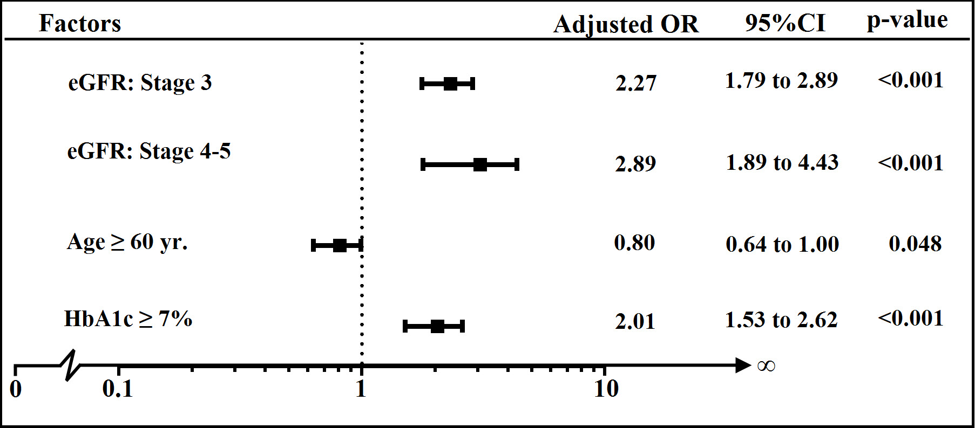

Fig. 2. Adjusted OR and 95%CI of factors

DISCUSSION
The present result found the elderly patients (≥ 60 years) [2,10–12]

poor glycemic control (HbA1c ≥ 7%)

The study found statistically significant association between eGFR and HNHS. Therefore, the eGFR is one of factor that recognizing the early signs of dehydration can help prevent this condition.

ETHICAL CONSIDERATION
The permission to study was granted by each of sampled hospitals. Obtaining written informed consent of all participating patients was done prior to access to their medical records. Data collection was done by participating hospital’s authorized skilled personnel who had been trained to protect the privacy of personal health information from unauthorized use, and deliberately engaged in the study.

ACKNOWLEDFMENTS
This study utilized data was based upon the study “An Assessment on Quality of Care among Patients Diagnosed with Type 2 Diabetes and Hypertension visiting Hospitals in care of Ministry of Public Health and Bangkok Metropolitan Administration in Thailand, 2010-2012” by the Thailand National Health Security Office (NHSO) and the Thailand Medical Research Network (MedResNet). The data was archived at the web site http://www.damus.in.th maintained by MedResNet.

REFERENCES
1. Umpierrez GE, Murphy MB, Kitabchi AE. Diabetic Ketoacidosis and Hyperglycemic Hyperosmolar Syndrome. Diabetes Spectr. 2002 Jan 1;15(1):28–36.
2. Carroll P, Matz R. Uncontrolled Diabetes Mellitus in Adults: Experience in Treating Diabetic Ketoacidosis and Hyperosmolar Nonketotic Coma with Low-Dose Insulin and a Uniform Treatment Regimen. Dia Care. 1983 Nov 1;6(6): 579–85.
3. Aubert R. Diabetes in America. DIANE Publishing; 1995.
4. Singhal PC, Abramovici M, Venkatesan J. Rhabdomyolysis in the hyperosmolal state. Am J Med. 1990 Jan;88(1):9–12.
5. Md DTJW, Rn LMT-M, Dona L. Goldman RN MPH, Ma SEE, EdD PSO. Hyperosmolarity and acidosis in diabetes mellitus. J Gen Intern Med. 1991 Nov 1;6(6):495–502.
6. Phillips PA, Rolls BJ, Ledingham JGG, Forsling ML, Morton JJ, Crowe MJ, et al. Reduced Thirst after Water Deprivation in Healthy Elderly Men. N Engl J Med. 1984;311(12):753–9.
7. Davis PJ, Davis FB. Water excretion in the elderly. Endocrinol Metab Clin North Am. 1987 Dec;16(4):867–75.
8. Levey AS, Stevens LA, Schmid CH, Zhang YL, Castro AF 3rd, Feldman HI, et al. A new equation to estimate glomerular filtration rate. Ann Intern Med. 2009 May 5;150(9):604–12.
9. The National Kidney Foundation - Kidney Disease, Outcomes Quality Initiative (NKF-K/DOQI) workgroup 2002. Normal GFR [Internet]. [cited 2013 Jul 25]. Available from: http://www.renal.org/whatwedo/InformationResources/CKDe GUIDE/NormalGFR.aspx
10. Sheppard MC, Wright AD. The Effect on Mortality of Low-Dose Insulin Therapy for Diabetic Ketoacidosis. Dia Care. 1982 Mar 1;5(2):111–3.
11. Malone ML, Gennis V, Goodwin JS. Characteristics of diabetic ketoacidosis in older versus younger adults. J Am Geriatr Soc. 1992 Nov;40(11):1100–4.
12. Kitabchi AE, Umpierrez GE, Murphy MB, Kreisberg RA. Hyperglycemic Crises in Adult Patients With Diabetes A consensus statement from the American Diabetes Association. Dia Care. 2006 Dec 1;29(12):2739–48.

