TITLE PAGE

Title: The association between eGFR and Hyperosmolar Non-Ketotic Hyperglycemia Syndrome in Diabetes type 2

Authors: Jitjira Chaiyarit¹, Bandit Thinkamrop², Cameron P. Hurst³

Affiliations: Faculty of Public Health , Khon Kaen University, Khon Kaen, Thailand

Corresponding authors:
Name: Bandit Thinkhamrop
Address: Department of Biostatistics and Demography, Faculty of Public Health, Khon Kaen University, Khon Kaen, 40002, Thailand
Telephone: +66-85-0011123
Fax: +66-43-362075
e-Mail: bandit@kku.ac.th

Type of contribution: Original research results

Running title: The association between eGFR and Hyperosmolar Non-Ketotic Hyperglycemia Syndrome

Number of words in the abstract: 1,959

Number of words in the text:

Number of tables: 4

Number of figures: 3

ABSTRACT

Background: Hyperosmolar Non-Ketotic Hyperglycemia Syndrome (HNHS) is a life-threatening complication of uncontrolled diabetes mellitus and often found in patients with type 2 diabetes and have suggested of that older age, stopping insulin or other medications that lower glucose levels, poor management of diabetes and impaired thirst were risk factors of HNHS. The testing of kidney working is an uncommon complication of HNHS but probably subclinical and thus underestimated.
Methods: A analytic study was conducted. All information were collected from medical records of all patients diagnosed with diabetes type 2 during 2010-2012. The HNHS was the main outcome of this study. This paper included 24,266 who have been only diabetes type 2. To find the association of eGFR and the HNHS was analyzed using multiple logistic regression.
Results: There were 24,266 diabetes type 2. There were 2.40% (95%CI: 2.21 to 2.60) were HNHS. They were mainly female (71.17%). Almost all of them, 82.60%, were stage 1-2 of eGFR with a mean eGFR of 84.22 ± 24.44 mL/minute/1.73m² (ranged: 0.46: 400.23) and mean of age 56.09 ± 10.90 year-old (ranged: 20 - 98).The percentage for uncontrolled HbA1c patients was 71.07 and receiving ACEI or ARB 21.89. However, after adjusted for age and HbA1C were affected by stage of eGFR (adjusted OR_{2(vs1)} = 2.08; 95% CI: 1.65 to 2.61; p = <0.001, adjusted OR_{3(vs1)} = 2.55; 95% CI: 1.68 to 3.89; p = <0.001).
Conclusion: The study found statistically significant association between eGFR and HNHS. Therefore, the eGFR is one of factor that recognizing the early signs of dehydration can help prevent this condition.
Keywords: diabetes type 2, eGFR, HNHS, Acute complications

INTRODUCTION
Hyperosmolar Non-Ketotic Hyperglycemia Syndrome (HNHS) is a life-threatening complication of uncontrolled diabetes mellitus and often found in patients with type 2 diabetes, is a serious condition most frequently seen in older persons. [1,2]. In adults HNHS, mortality rate is about 15% [3]. Complications associated with HHNS include severe metabolic disturbances, renal impairment, and cardiovascular, thromboembolic, and neurological events [4]. The most recent papers indicated risk factors of HNHS are the elderly patients with non-insulin-dependent diabetes mellitus or other medications that lower glucose levels, poor management of diabetes and impaired thirst [2,5–7]. The testing of kidney working is an uncommon complication of HNHS but probably subclinical and thus underestimated. In this study, we investigated whether the association between eGFR and HNHS.

METHODS
Study participants
An analytic study was conducted. All information were collected from medical records of all patients diagnosed with diabetes type 2 during 2010-2012. The type of diabetic acute complications was based on medical records while HNHS was the main outcome of this study. The study subjects consisted of 24,038 who have been detected HNHS. Patients were excluded from participation in the study if either of the following criteria applied: i) under age of 18, or ii) not been examined serum creatinine.

Data collection and clinical evaluation
This paper is part of the An Assessment on Quality of Care among Patients Diagnosed with Type 2 Diabetes and Hypertension visiting Hospitals in care of Ministry of Public Health and Bangkok Metropolitan Administration in Thailand, 2010-2012. The sampling method was stratified cluster sampling with probability proportional to size Hospitals in care of Ministry of Public Health and Bangkok Metropolitan Administration in Thailand.
Age (year), gender, serum creatinine (mg/dL), receiving ACEI or ARB and hemoglobin A1C (HbA1C) were ascertained from review of medical records. The estimated glomerular filtration rate (eGFR: mL/minute/1.73m²) was recalculated as age in year and serum creatinine in mg/dL by Chronic Kidney Disease Epidemiology Collaboration formula (CKD-EPI). The CKD-EPI formulas, expressed as two equations, are [8]:
For male:
For female:
Where sCr is serum creatinine (mg/dL).

Table 1. The Kidney Disease Outcomes Quality Initiative stages of kidney disease [9]

Stages of kidney disease | eGFR (mL/minute/1.73m²)
Stage 1 - 2 | ≥ 60
Stage 3 | 30-59
Stage 4 - 5 | ≤ 29

Statistical analysis
For demographic characteristics all the continuous variables were presented as mean and standard deviation and all the categorical variables were presented as frequency and percentage. Logistic regression models were used to examine the statistical difference of proportions and estimate the odd ratios adjusted for eGFR and potential confounding factors. STATA (StataCorp, TX) was used for all data analysis.

Research frame
150,312 were excluded
95,035 were only HT
55,277 were DM+HT

3,373,089 patients who visiting Hospitals in care
24,266 patients were only DM

24,038 patients who have been detected HNHS
(Missing of HNHS (228))

174,578 patients were randomized

Fig. 1. Identification of patients for inclusion
Ethical Consideration
The permission to study was granted by each of sampled hospitals. Obtaining written informed consent of all participating patients was done prior to access to their medical records. Data collection was done by participating hospital’s authorized skilled personnel who had been trained to protect the privacy of personal health information from unauthorized use, and deliberately engaged in the study.

RESULTS
Baseline characteristics of the participants
Of the 24,133 DM patients, almost all of them, 82.60%, were stage 1-2 of eGFR with a mean eGFR of 84.22 ± 24.44 mL/minute/1.73m² (Table 1). They were mainly female (71.17%), with a mean age of 56.09 ± 10.90 year-old (ranged: 20 - 98) currently received ACEI or ARB (21.89%) and a mean HbA1C of 8.33 ± 2.14 % (ranged: 0.10 - 20.50)

Table 2. Baseline characteristics presented as number and percentage unless specified otherwise

Baseline characteristics | Number | Percent
eGFR (mL/minute/1.73m²)
Stage 1-2 | 19,933 | 82.60
Stage 3 | 3,477 | 14.41
Stage 4-5 | 723 | 3.00
Total | 24,133 | 100.00
Mean (SD) | 84.22 (24.44)
Median (Min: Max) | 91.22 (0.46: 400.23)
Gender
Male | 6,995 | 28.83
Female | 17,268 | 71.17
Total | 24,263 | 100.00

Table 2. Baseline characteristics presented as number and percentage unless specified otherwise (Cont.)

Baseline characteristics | Number | Percent
Age (years)
< 60 years | 15,246 | 62.88
≥ 60 years | 8,999 | 37.12
Total | 24,245 | 100.00
Mean ± standard deviation | 56.09 (10.90)
Median (Min:Max) | 56 (20 : 98)
Receiving ACEI or ARB
No | 14,968 | 78.11
Yes | 4,194 | 21.89
Total | 19,162
HbA1C
< 7% | 5,107 | 28.93
≥ 7% | 12,546 | 71.07
Total | 17,653 | 100.00
Mean ± standard deviation | 8.33 (2.14)
Median (Min:Max) | 7.90 (0.10 : 20.50)

Factors associated with HNHS
Univariate Analysis
The strongest factor that associated to HNHS of all types was eGFR. That is, the patients who had eGFR was stage 3 were 2.26 times the risk of the HNHS compared to who had eGFR was stage 1-2 (OR = 2.26; 95%CI: 1.87 to 2.74; p < 0.001) and the patients who had eGFR was stage 4-5 were 2.37 times the risk of the HNHS compared to who had eGFR was stage 1-2 (OR = 2.37; 95%CI: 1.65 to 3.41; p < 0.001) (Table 3). The second strongest factor was HbA1C (OR = 2.02; 95%CI: 1.55 to 2.64; p < 0.001). Others factors that were not significant factors, p>0.05.

Table 3. Crude Odds ratios (OR) and their 95% confidence intervals of having HNHS for each factor presented in the table using logistic regression

Variable | Total | % HNHS | Crude OR | 95%CI |  | p-value
eGFR |  |  |  |  |  | <0.001
Stage 1-2 | 19,933 | 1.98 | 1
Stage 3 | 3,477 | 4.37 | 2.26 | 1.87 | to 2.74
Stage 4-5 | 723 | 4.56 | 2.37 | 1.65 | to 3.41
Gender |  |  |  |  |  | 0.841
Male | 6,921 | 2.37 | 1
Female | 17,114 | 2.41 | 1.02 | 0.85 | to 1.22
Age |  |  |  |  |  | 0.721
< 60 years | 15,106 | 2.43 | 1
≥ 60 years | 8,911 | 2.36 | 0.97 | 0.82 | to 1.15
Receiving ACEI or ARB |  |  |  |  |  | 0.787
No | 14,968 | 2.71 | 1
Yes | 4,194 | 2.79 | 1.03 | 0.84 | to 1.27
HbA1C |  |  |  |  |  | <0.001
< 7% | 5,106 | 1.29 | 1
≥ 7% | 12,546 | 2.58 | 2.02 | 1.55 | to 2.64

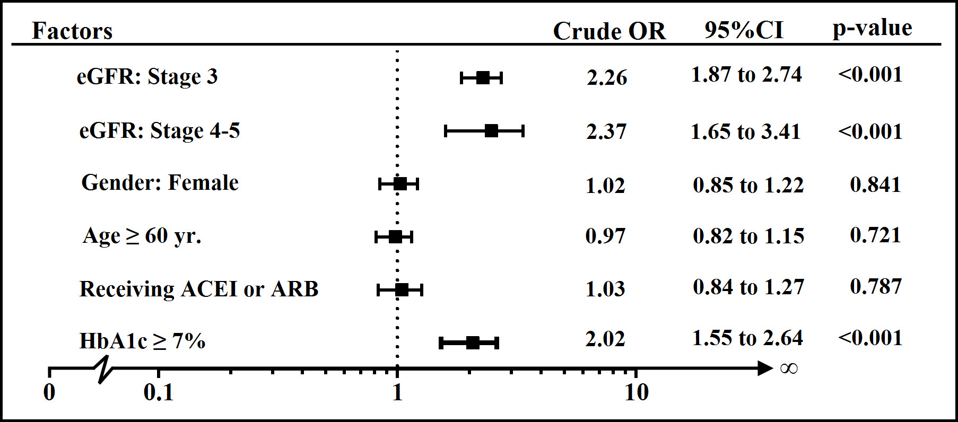
Fig. 2. Forest plot of crude odds ratio for compare having HNHS for each factor

Multivariate Analysis
All the variables with a significant impact (p<0.20) in the univariate analysis (Table 3) were considered for the multivariate analysis. After adjusted for age and HbA1C in the Logistic regression model found that the patients who had eGFR was stage 3 were 2.27 times the risk of the HNHS compared to who had eGFR was stage 1-2 (OR = 2.27; 95%CI: 1.79 to 2.89; p < 0.001) and the patients who had eGFR was stage 4-5 were 2.89 times the risk of the HNHS compared to who had eGFR was stage 1-2 (OR = 2.89; 95%CI: 1.89 to 4.43; p < 0.001) (Table 4).

Table 4. Crude and Adjusted Odds Ratio and their 95% confidence intervals of having HNHS for all other factors presented in the table using multiple logistic regression

Variable | Total | % HNHS | Crude OR | Adj. OR | 95%CI |  | p-value
eGFR |  |  |  |  |  |  | <0.001
Stage 1-2 | 19,933 | 1.98 | 1 | 1
Stage 3 | 3,477 | 4.37 | 2.26 | 2.27 | 1.79 | to 2.89
Stage 4-5 | 723 | 4.56 | 2.37 | 2.89 | 1.89 | to 4.43
Age |  |  |  |  |  |  | 0.048
< 60 years | 15,106 | 2.43 | 1 | 1
≥ 60 years | 8,911 | 2.36 | 0.97 | 0.80 | 0.64 | to 1.00
HbA1C |  |  |  |  |  |  | <0.001
< 7% | 5,106 | 1.29 | 1 | 1
≥ 7% | 12,546 | 2.58 | 2.02 | 2.01 | 1.53 | to 2.62

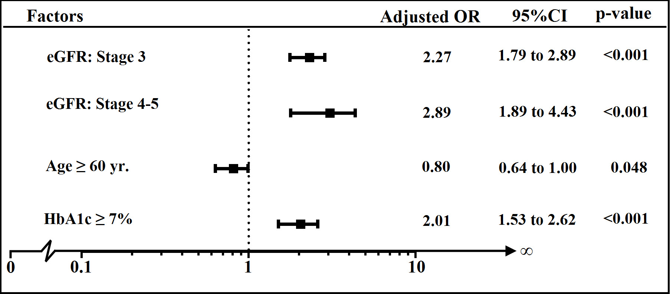
Fig. 3. Forest plot of adjusted odds ratio for compare having HNHS for each factor
DISCUSSION
The study found statistically significant association between eGFR and HNHS. The eGFR is an interactive tool to help measure renal function. The patients with low eGFR (< 29 mL/minute/1.73m²: stages of kidney disease was 4-5) had risk effect (adj.OR=2.89) for having HNHS. This is consistent with a previous finding [6,7,10,11] that . If renal function declined, it was cause of glucosuria that is nearly always caused by elevated blood glucose levels which was a risk factor of HNHS.
The present result found the elderly patients (≥ 60 years) significant association with HNHS. From result, age is protective factor (adj.OR=0.80) that contrasts with research in the past which found the average age of patients with HNHS is 60 years [2,12–14]. Most published series report an average age of 57-69 years at diagnosis [15–17]. In the other hand, the previous research has demonstrated that HNHS may also occur in younger people. In particular, as rates of obesity increase in children, the prevalence of type 2 DM is also rising in this age group and may lead to an increased incidence of HNHS in this population [18–20].
The patients who had poor glycemic control (HbA1c ≥ 7%) were at greater risk (adj.OR=2.01) for HNHS. This finding suggests that in those who have not been able to control their diabetes, HNHS will occur. This result supports past studies [21,22] showing that the patients were poor management of diabetes if blood sugar levels continue to rise and left untreated, this can result in diabetic coma and death.

ACKNOWLEDFMENTS
This study utilized data was based upon the study “An Assessment on Quality of Care among Patients Diagnosed with Type 2 Diabetes and Hypertension visiting Hospitals in care of Ministry of Public Health and Bangkok Metropolitan Administration in Thailand, 2010-2012” by the Thailand National Health Security Office (NHSO) and the Thailand Medical Research Network (MedResNet). We gratefully acknowledge research assistants, and patients who participated in this study.

REFERENCES
1. Umpierrez GE, Murphy MB, Kitabchi AE. Diabetic Ketoacidosis and Hyperglycemic Hyperosmolar Syndrome. Diabetes Spectr. 2002 Jan 1;15(1):28–36.
2. Carroll P, Matz R. Uncontrolled Diabetes Mellitus in Adults: Experience in Treating Diabetic Ketoacidosis and Hyperosmolar Nonketotic Coma with Low-Dose Insulin and a Uniform Treatment Regimen. Dia Care. 1983 Nov 1;6(6):579–85.
3. Aubert R. Diabetes in America. DIANE Publishing; 1995.
4. Singhal PC, Abramovici M, Venkatesan J. Rhabdomyolysis in the hyperosmolal state. Am J Med. 1990 Jan;88(1):9–12.
5. Md DTJW, Rn LMT-M, Dona L. Goldman RN MPH, Ma SEE, EdD PSO. Hyperosmolarity and acidosis in diabetes mellitus. J Gen Intern Med. 1991 Nov 1;6(6):495–502.
6. Phillips PA, Rolls BJ, Ledingham JGG, Forsling ML, Morton JJ, Crowe MJ, et al. Reduced Thirst after Water Deprivation in Healthy Elderly Men. N Engl J Med. 1984;311(12):753–9.
7. Davis PJ, Davis FB. Water excretion in the elderly. Endocrinol Metab Clin North Am. 1987 Dec;16(4):867–75.
8. Levey AS, Stevens LA, Schmid CH, Zhang YL, Castro AF 3rd, Feldman HI, et al. A new equation to estimate glomerular filtration rate. Ann Intern Med. 2009 May 5;150(9):604–12.
9. The National Kidney Foundation - Kidney Disease, Outcomes Quality Initiative (NKF-K/DOQI) workgroup 2002. Normal GFR [Internet]. [cited 2013 Jul 25]. Available from: http://www.renal.org/whatwedo/InformationResources/CKDeGUIDE/NormalGFR.aspx
10. Remuzzi A, Viberti G, Ruggenenti P, Battaglia C, Pagni R, Remuzzi G. Glomerular response to hyperglycemia in human diabetic nephropathy. Am J Physiol. 1990 Oct;259(4 Pt 2):F545–552.
11. Toprak Ö, Cirit M, Ersoy R, Üzüm A, Özümer Ö, Çobanoğlu A, et al. New-onset type II diabetes mellitus, hyperosmolar non-ketotic coma, rhabdomyolysis and acute renal failure in a patient treated with sulpiride. Nephrol Dial Transplant. 2005 Mar 1;20(3):662–3.
12. Sheppard MC, Wright AD. The Effect on Mortality of Low-Dose Insulin Therapy for Diabetic Ketoacidosis. Dia Care. 1982 Mar 1;5(2):111–3.
13. Malone ML, Gennis V, Goodwin JS. Characteristics of diabetic ketoacidosis in older versus younger adults. J Am Geriatr Soc. 1992 Nov;40(11):1100–4.
14. Kitabchi AE, Umpierrez GE, Murphy MB, Kreisberg RA. Hyperglycemic Crises in Adult Patients With Diabetes A consensus statement from the American Diabetes Association. Dia Care. 2006 Dec 1;29(12):2739–48.
15. Nugent BW. Hyperosmolar Hyperglycemic State. Emerg Med Clin North Am. 2005 Aug;23(3):629–48.
16. Trence DL, Hirsch IB. Hyperglycemic crises in diabetes mellitus type 2. Endocrinol Metab Clin North Am. 2001 Dec;30(4):817–31.
17. MacIsaac RJ, Lee LY, McNeil KJ, Tsalamandris C, Jerums G. Influence of age on the presentation and outcome of acidotic and hyperosmolar diabetic emergencies. Intern Med J. 2002 Aug;32(8):379–85.
18. Carchman RM, Dechert-Zeger M, Calikoglu AS, Harris BD. A new challenge in pediatric obesity: pediatric hyperglycemic hyperosmolar syndrome. Pediatr Crit Care Med J Soc Crit Care Med World Fed Pediatr Intensive Crit Care Soc. 2005 Jan;6(1):20–4.
19. Kershaw MJR, Newton T, Barrett TG, Berry K, Kirk J. Childhood diabetes presenting with hyperosmolar dehydration but without ketoacidosis: a report of three cases. Diabet Med J Br Diabet Assoc. 2005 May;22(5):645–7.
20. Bhowmick SK, Levens KL, Rettig KR. Hyperosmolar hyperglycemic crisis: an acute life-threatening event in children and adolescents with type 2 diabetes mellitus. Endocr Pr Off J Am Coll Endocrinol Am Assoc Clin Endocrinol. 2005 Feb;11(1):23–9.
21. Kitabchi AE, Nyenwe EA. Hyperglycemic crises in diabetes mellitus: diabetic ketoacidosis and hyperglycemic hyperosmolar state. Endocrinol Metab Clin North Am. 2006 Dec;35(4):725–751, viii.
22. Tupola S, Rajantie J, Mäenpää J. Severe hypoglycaemia in children and adolescents during multiple-dose insulin therapy. Diabet Med J Br Diabet Assoc. 1998 Aug;15(8):695–9.

