TITLE PAGE

Title: The association between eGFR and Hyperosmolar Non-Ketotic Hyperglycemia Syndrome in Diabetes type 2

Authors: Jitjira Chaiyarit¹, Bandit Thinkamrop², Cameron P. Hurst³

Affiliations: Faculty of Public Health , Khon Kaen University, Khon Kaen, Thailand

Corresponding authors:
Name: Bandit Thinkhamrop
Address: Department of Biostatistics and Demography, Faculty of Public Health, Khon Kaen University, Khon Kaen, 40002, Thailand
Telephone: +66-85-0011123
Fax: +66-43-362075
e-Mail: bandit@kku.ac.th

Type of contribution: Original research results

Running title: The association between eGFR and Hyperosmolar Non-Ketotic Hyperglycemia Syndrome

Number of words in the abstract: 1,739

Number of words in the text:

Number of tables: 4

Number of figures: 3

ABSTRACT

Background: Hyperosmolar Non-Ketotic Hyperglycemia Syndrome (HNHS) is a life-threatening complication of uncontrolled diabetes mellitus and often found in patients with type 2 diabetes and the most recent papers indicated risk factors of HNHS are older age, stopping insulin or other medications that lower glucose levels, poor management of diabetes and impaired thirst. The testing of kidney working is an uncommon complication of HNHS but probably subclinical and thus underestimated.
Methods: A analytic study was conducted. All information were collected from medical records of all patients diagnosed with diabetes type 2 during 2010-2012. The HNHS was the main outcome of this study. This paper included 79,543 who have been diabetes type 2. To find the association of eGFR and the HNHS was analyzed using multiple logistic regression.
Results: There were 79,290 diabetes type 2. There were 2.31% (95%CI: 2.20 to 2.41) were HNHS. Almost all of them, 59.14% were stage 1-2 of eGFR with a mean eGFR of 67.46±26.15 mL/minute/1.73m² (ranged: 1.23: 199.46), 69.49% were both DM and HT. They were mainly female (69.96%) and mean of age 59.83±10.77 year-old (ranged: 20 - 98). The percentage for receiving ACEI or ARB 51.79 and uncontrolled fasting plasma glucose (FPG) patients was 58.17 with mean of FPG 150.97±56.87. However, after adjusted for HT and FPG were affected by stage of eGFR (adj. OR_{2(vs1)}=1.42; 95% CI: 1.27 to 1.59, adj. OR_{3(vs1)}=1.89; 95% CI: 1.59 to 2.26).
Conclusion: The study found statistically significant association between eGFR and HNHS. Therefore, the eGFR is one of factor that recognizing the early signs of dehydration can help prevent this condition.
Keywords: diabetes type 2, eGFR, HNHS, Acute complications

INTRODUCTION
Hyperosmolar Non-Ketotic Hyperglycemia Syndrome (HNHS) is a life-threatening complication of uncontrolled diabetes mellitus and often found in patients with type 2 diabetes, is a serious condition most frequently seen in older persons [1,2]. In adults HNHS, mortality rate is about 15% [3]. The most recent papers indicated risk factors of HNHS are the elderly patients with non-insulin-dependent diabetes mellitus or other medications that lower glucose levels, poor management of diabetes and impaired thirst [2,4–6]. The testing of kidney working is an uncommon complication of HNHS but probably subclinical and thus underestimated. In this study, we investigated whether the association between the estimated glomerular filtration rate (eGFR) and HNHS.

MATERIALS AND METHODS
Study participants
A Cross-sectional analytical was conducted. All information were collected from medical records of all patients diagnosed with diabetes type 2 during 2010-2012. The type of diabetic acute complications was based on medical records while HNHS was the main outcome of this study. The study subjects consisted of 79,543 patients were only DM and both DM and HT. Patients were excluded from participation in the study if either of the following criteria applied: were diagnosed with hypertension.
Data collection and clinical evaluation
This paper was part of the An Assessment on Quality of Care among Patients Diagnosed with Type 2 Diabetes and Hypertension visiting Hospitals in care of Ministry of Public Health and Bangkok Metropolitan Administration in Thailand, 2010-2012. The sampling method was stratified cluster sampling with probability proportional to size Hospitals in care of Ministry of Public Health and Bangkok Metropolitan Administration in Thailand.
Age (year), gender, serum creatinine (mg/dL), receiving ACEI or ARB and fasting plasma glucose (FPG) (mg/dL) were ascertained from review of medical records. The eGFR (mL/minute/1.73m²) was recalculated as gender, age in year and serum creatinine in mg/dL by Chronic Kidney Disease Epidemiology Collaboration formula (CKD-EPI). The CKD-EPI formulas, expressed as two equations, were [7]:

For male:
For female:
Where sCr is serum creatinine (mg/dL).

The eGFR was used to measure the severity of kidney damage. Because it was normally about 100 it gives an approximate “% kidney function”. The K/DOQI CKD stages distinguish 5 grades of severity which can be useful in planning management. Remember that eGFR was an estimate value, in some case it is not possible to tell apart stage 1 and 2 CKD or stage 4 and 5 CKD. Therefore, the rationale for including individuals with stages 1 and 2 CKD was that GFR may be sustained at normal or increased levels, also with stage 4 and 5 CKD. The eGFR was created to 3 stages that follow as table 1.

Table 1. The Kidney Disease Outcomes Quality Initiative stages of kidney disease [8]

Stages of kidney disease | eGFR (mL/minute/1.73m²)
Stage 1-2 | ≥ 60
Stage 3 | 30-59
Stage 4-5 | ≤ 29

Statistical analysis
For demographic characteristics all the continuous variables were presented as mean and standard deviation and all the categorical variables were presented as frequency and percentage. Logistic regression models were used to examine the statistical difference of proportions and estimate the odd ratios adjusted for eGFR and potential confounding factors. STATA (StataCorp, TX) was used for all data analysis.

95,035 were excluded (only HT)
79,543 patients were only DM and
Both DM and HT

79,290 patients who have been detected HNHS
(Missing of HNHS (253))

174,578 patients were randomized

Fig. 1. Identification of patients for inclusion

Ethical Consideration
The permission to study was granted by each of sampled hospitals. Obtaining written informed consent of all participating patients was done prior to access to their medical records. Data collection was done by participating hospital’s authorized skilled personnel who had been trained to protect the privacy of personal health information from unauthorized use, and deliberately engaged in the study.

RESULTS
Baseline characteristics of the participants
Of the 63,218 DM patients, almost all of them, 59.14%, were stage 1-2 of eGFR with a mean eGFR of 67.46 ± 26.15 mL/minute/1.73m² (Table 1). They were mainly both DM and HT69.49%. They were mainly female (69.96%) and mean of age 59.83±10.77 year-old (ranged: 20 - 98). The percentage for receiving ACEI or ARB 51.79 and uncontrolled fasting plasma glucose (FPG) patients was 58.17 with median of FPG 138 (5: 902).

Table 2. Baseline characteristics presented as number and percentage unless specified otherwise

Baseline characteristics | Number | Percent
estimated Glomerular Filtration Rate
: eGFR (mL/minute/1.73m²): Mean (SD) | 67.46 (26.15)
Stage 1-2 | 37,387 | 59.14
Stage 3 | 20,987 | 33.20
Stage 4-5 | 4,844 | 7.66
Total | 63,218 | 100.00
Median (Min: Max) | 66.56 (1.23: 199.46)
No Hypertension (n = 79,543) | 24,266 | 30.51
Female (n = 79,535) | 55,641 | 69.96
Age (years): Mean (SD) | 59.83(10.77)
< 60 years | 38,832 | 48.84
≥ 60 years | 40,674 | 51.16
Total | 79,506 | 100.00
Median (Min:Max) | 60 (20 : 98)
Receiving ACEI or ARB (n = 63,460) | 32,867 | 51.79
Fasting Plasma Glucose: Median (Min:Max) | 138 (5 : 902)
FPG (mg/dL)
≤ 130 | 28,409 | 41.83
> 130 | 39,509 | 58.17
Total | 67,918 | 100.00
Mean (SD) | 150.97 (56.87)

Factors associated with HNHS
Univariate Analysis
Among a total of 79,290 patients, 1,828 had HNHS. The HNHS rate was 2.31% (95%CI: 2.20 to 2.41). The patients who had eGFR stage 3 were 1.27 times more likely to have HNHS than those had eGFR stage 1-2 (95%CI: 1.14 to 1.41) and the patients who had eGFR stage 4-5 were 1.79 times more likely to have HNHS than those had eGFR stage 1-2 (95%CI: 1.52 to 2.10). The following factor was statistically significant associated with HNHS, Fasting Plasma Glucose (FPG) (OR = 1.58; 95%CI: 1.42 to 1.76; p-value < 0.001). Others following factors were not significant factors, p>0.05 (Table 3).

Table 3. Crude Odds ratios (OR) and their 95% confidence intervals of having HNHS for each factor presented in the table using logistic regression

Variable | Total | % HNHS | Crude OR | 95%CI |  | p-value
estimated Glomerular Filtration Rate |  |  |  |  |  | <0.001
: eGFR (mL/minute/1.73m²)
Stage 1-2 | 37,387 | 2.26 | 1
Stage 3 | 20,987 | 2.85 | 1.27 | 1.14 | to 1.41
Stage 4-5 | 4,844 | 3.96 | 1.79 | 1.52 | to 2.10
No Hypertension | 24,038 | 2.40 | 1.06 | 0.96 | to 1.17 | 0.242
Female | 55,471 | 2.32 | 1.02 | 0.93 | to 1.13 | 0.641
Age ≥ 60 years | 40,567 | 2.34 | 1.03 | 0.94 | to 1.13 | 0.529
Receiving ACEI or ARB | 32,867 | 2.61 | 0.93 | 0.85 | to 1.03 | 0.146
Fasting Plasma Glucose > 130 mg/dL | 39,509 | 2.78 | 1.58 | 1.42 | to 1.76 | < 0.001

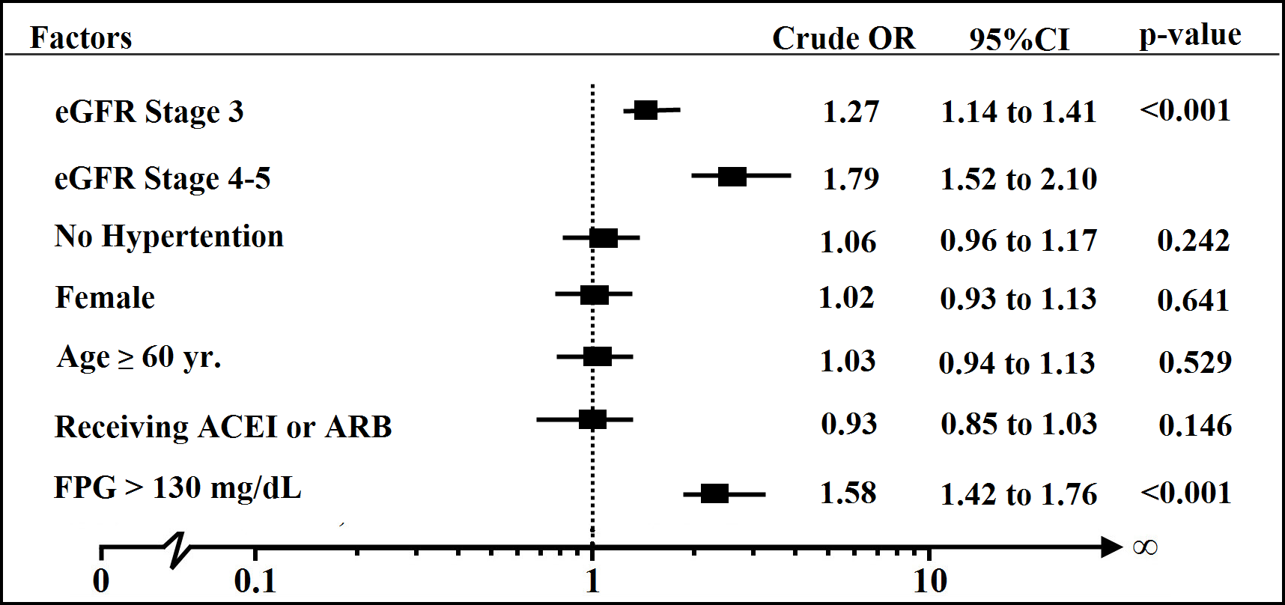

Fig. 1. Forest plot of crude odds ratio for compare having HNHS for each factor

Multivariate Analysis
All the variables with a significant impact (p<0.25) in the univariate analysis (Table 3) were considered for the multivariate analysis found that eGFR was statistically significant associated with HNHS (p-value < 0.001). That is, the patients who had eGFR stage 3 were 1.42 times more likely to have HNHS than those had eGFR stage 1-2 (95%CI: 1.27 to 1.59) and the patients who had eGFR stage 4-5 were 1.89 times more likely to have HNHS than those had eGFR stage 1-2 (95%CI: 1.59 to 2.26). These effects have also been adjusted for the effect of on hypertension and level of FPG. No hypertension has significant risk effect on HNHS (OR_{adj.}=1.48; 95%CI: 1.32 to 1.67). Similarly, level of FPG has significant risk effect on HNHS (OR_{adj.}=1.64; 95%CI: 1.47 to 1.83) (Table 4).

Table 4. Crude and Adjusted Odds Ratio and their 95% confidence intervals of having HNHS for all other factors presented in the table using multiple logistic regression

Variable | Total | % HNHS | Crude OR | Adj. OR | 95%CI |  | p-value
estimated Glomerular Filtration Rate |  |  |  |  |  |  | <0.001
: eGFR (mL/minute/1.73m²)
Stage 1-2 | 37,387 | 2.26 | 1 | 1
Stage 3 | 20,987 | 2.85 | 1.27 | 1.42 | 1.27 | to 1.59
Stage 4-5 | 4,844 | 3.96 | 1.79 | 1.89 | 1.59 | to 2.26
No Hypertension | 24,038 | 2.40 | 1.06 | 1.48 | 1.32 | to 1.67 | <0.001
Fasting Plasma Glucose > 130 mg/dL | 39,509 | 2.78 | 1.58 | 1.64 | 1.47 | to 1.83 | <0.001

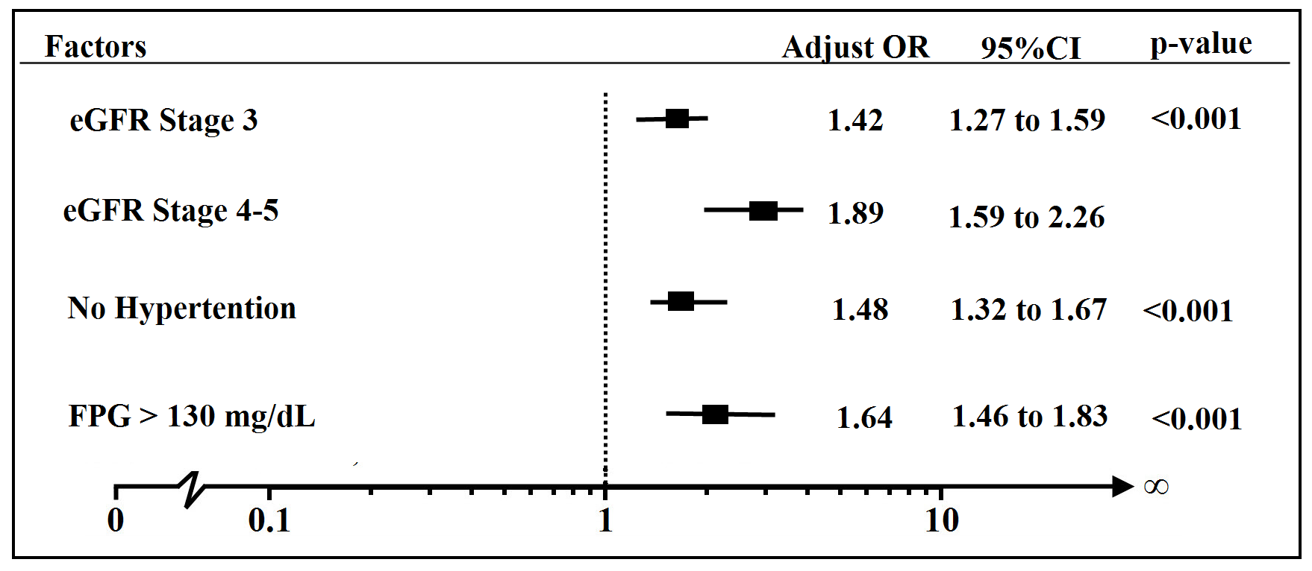
Fig. 2. Forest plot of adjusted odds ratio for compare having HNHS for each factor
DISCUSSION
This study explored the association of eGFR and HNHS in diabetes type 2, found statistically significant association between eGFR and HNHS. That is, comparing to have a stage of eGFR at 1-2, those who at stage 3 has a higher risk to having HNHS and also at stage 4-5. In this study found that the risk of having HNHS increased when the eGFR value decreased. It is known that HNHS is a condition of extremely high blood sugar (glucose) levels, extreme lack of water and decreased consciousness. It may occur in those who have not been diagnosed with diabetes, or in people who have not been able to control their diabetes [9].
This study was consistent with a previous finding [10,11] that if renal function declined, it was cause of glucosuria that was nearly always caused by elevated blood glucose levels which was a risk factor for HNHS. In the other hand, some previous studies [10,12,13] found that there is the association between poor glycemic control and increased GFR is well known in early diabetes. Indeed the reduction in A1C after a few months on diet or oral hypoglycemic agents is associated with a significant reduction in GFR [14,15]. There is conflict of interest in research, the future studies with longer follow-up and sufficient numbers of subjects would be necessary to elucidate the effects of eGFR on HNHS.
Some limitations of this study need to be mentioned. First, the validity for using the dataset, there was 0.32% of the sample lost to detecting HNHS and missing data for serum creatinine was around 20.4%. The insufficient data and missing values in the data because the information was secondary data and cannot recheck data. Finally, the outliers of eGFR that were recalculated have to cutoff, because it will make the underestimation of GFR at the high values up to 200 mL/minute/1.73m²and the overestimation of eGFR at the low values less than 1 mL/minute/1.73m².

ACKNOWLEDFMENTS
This study utilized data was based upon the study “An Assessment on Quality of Care among Patients Diagnosed with Type 2 Diabetes and Hypertension visiting Hospitals in care of Ministry of Public Health and Bangkok Metropolitan Administration in Thailand, 2010-2012” by the Thailand National Health Security Office (NHSO) and the Thailand Medical Research Network (MedResNet). We gratefully acknowledge research assistants, and patients who participated in this study.

REFERENCES
1. Umpierrez GE, Murphy MB, Kitabchi AE. Diabetic Ketoacidosis and Hyperglycemic Hyperosmolar Syndrome. Diabetes Spectr. 2002 Jan 1;15(1):28–36.
2. Carroll P, Matz R. Uncontrolled Diabetes Mellitus in Adults: Experience in Treating Diabetic Ketoacidosis and Hyperosmolar Nonketotic Coma with Low-Dose Insulin and a Uniform Treatment Regimen. Dia Care. 1983 Nov 1;6(6):579–85.
3. Aubert R. Diabetes in America. DIANE Publishing; 1995.
4. Md DTJW, Rn LMT-M, Dona L. Goldman RN MPH, Ma SEE, EdD PSO. Hyperosmolarity and acidosis in diabetes mellitus. J Gen Intern Med. 1991 Nov 1;6(6):495–502.
5. Phillips PA, Rolls BJ, Ledingham JGG, Forsling ML, Morton JJ, Crowe MJ, et al. Reduced Thirst after Water Deprivation in Healthy Elderly Men. N Engl J Med. 1984;311(12):753–9.
6. Davis PJ, Davis FB. Water excretion in the elderly. Endocrinol Metab Clin North Am. 1987 Dec;16(4):867–75.
7. Levey AS, Stevens LA, Schmid CH, Zhang YL, Castro AF 3rd, Feldman HI, et al. A new equation to estimate glomerular filtration rate. Ann Intern Med. 2009 May 5; 150(9): 604–12.
8. The National Kidney Foundation - Kidney Disease, Outcomes Quality Initiative (NKF-K/DOQI) workgroup 2002. Normal GFR [Internet]. [cited 2013 Jul 25]. Available from: http://www.renal.org/whatwedo/InformationResources/CKDeGUIDE/NormalGFR.aspx
9. Diabetic hyperglycemic hyperosmolar syndrome: MedlinePlus Medical Encyclopedia [Internet]. [cited 2013 Aug 26]. Available from: http://www.nlm.nih.gov/medlineplus/ ency/article/000304.htm
10. Remuzzi A, Viberti G, Ruggenenti P, Battaglia C, Pagni R, Remuzzi G. Glomerular response to hyperglycemia in human diabetic nephropathy. Am J Physiol. 1990 Oct;259(4 Pt 2):F545–552.
11. Toprak Ö, Cirit M, Ersoy R, Üzüm A, Özümer Ö, Çobanoğlu A, et al. New-onset type II diabetes mellitus, hyperosmolar non-ketotic coma, rhabdomyolysis and acute renal failure in a patient treated with sulpiride. Nephrol Dial Transplant. 2005 Mar 1;20(3):662–3.
12. Christensen PK, Lund S, Parving HH. The impact of glycaemic control on autoregulation of glomerular filtration rate in patients with non-insulin dependent diabetes. Scand J Clin Lab Invest. 2001 Feb;61(1):43–50.
13. Rigalleau V, Lasseur C, Raffaitin C, Perlemoine C, Barthe N, Chauveau P, et al. Glucose Control Influences Glomerular Filtration Rate and Its Prediction in Diabetic Subjects. Dia Care. 2006 Jul 1;29(7):1491–5.
14. Vora JP, Dolben J, Williams JD, Peters JR, Owens DR. Impact of initial treatment on renal function in newly-diagnosed type 2 (non-insulin-dependent) diabetes mellitus. Diabetologia. 1993 Aug;36(8):734–40.
15. Ahmad J, Singh M, Kumar S. Kidney functions in newly diagnosed type 2 diabetic subjects: role of glycemic control. J Assoc Physicians India. 2002 Jul;50:882–6.

