TITLE PAGE

Title: Relationship between secondhand smoking in pregnant women and the time of first tooth eruption in infants.
Authors: Vu Hoa Anh Dien¹, Bandit Thinkhamrop² , <Others to be added>
Affiliations:
¹ Department of Community Dentistry, Faculty of Dentistry, Khon Kaen University, Thailand
² Department of Biostatistics and Demography, Faculty of Public Health, Khon Kaen University, Thailand
Corresponding authors:
Name: Bandit Thinkhamrop
Address: Department of Biostatistics and Demography, Faculty of Public Health, Khon Kaen University, Khon Kaen, 40002, Thailand
Telephone: +66-85-0011123
Fax: +66-43-362075
E-mail: bandit@kku.ac.th
Type of contribution: Original research results
Running title: Secondhand smoking and first tooth eruption
Number of words in the abstract: 281
Number of words in the text: 3,236
Number of tables: 6
Number of figures: 3

ABSTRACT

Background: The deciduous teeth are very important to the development of infants in terms of speaking, chewing and holding space for the permanent teeth. Smoking is very common in Thai people, especially males. Women and children are also affected by their behaviors. There are not many studies examining the association between secondhand smoking in pregnant women and the time of first tooth eruption.
Objective: To evaluate the association between secondhand smoking in pregnant women and delayed time of first tooth eruption in infants.
Methods: Data from the Prospective Cohort Study of Thai Children (PCTC) was used to record the exposure of secondhand smoking in pregnant women. PCTC is a large birth cohort study which was conducted on more than 4,000 infants born from October 2000 to September 2002 and their parents or caregivers in five different regions in Thailand. Dental records of children were followed by questionnaires from three months of age until the time of first tooth eruption. Multiple logistic regression and Cox proportional regression analysis were applied using Stata SE 12.0.
Results: The mean age of first tooth eruption was 7.59 ± 2.4 months. 45.42% of 4,654 subjects are secondhand smokers during the third trimester of pregnancy. The risk of having delayed first tooth eruption among secondhand smoking mothers is 1.22 times higher than that among non-smokers (95% confidence interval 1.05 – 1.42). Secondhand smoking mothers face a hazard of not erupted tooth 2% greater than non-secondhand smoking mothers (adjusted HR = 0.98, 95% confidence interval 0.89 – 1.08).
Conclusion: Secondhand smoking in Thai pregnant women delayed the time of the first tooth eruption in infants up to x.x weeks.
Keywords: Deciduous teeth, eruption, secondhand smoking, Thai pregnant women, infant

INTRODUCTION
Delayed first tooth eruption (DTE) can cause many problems in the dental development of infants because deciduous teeth not only help to hold space in the jaws for the permanent teeth and align them into correct position , but also permit infants to chew and speak properly. There are many factors which may influence the time of tooth eruption including genetics, gender, ethnicity, social economic status, nutrition , and neonatal factors . However, role of secondhand smoking (SHS) on DTE has not yet been broadly established.
Many studies have reported the negative effect of smoking during pregnancy on children , particularly on the time of first tooth eruption . Smoking is very common in Thai people, especially among males. Women and children are also affected by their behaviors. This leads to a high prevalence (29.8%) of secondhand smoking exposure among Thai women .
Being aware of such risk factors, we could help improve the dental development of infants. However, little was known about this association in Thai population. Hence, we conducted this study to determine whether secondhand smoking during pregnancy period delayed the time of first tooth eruption in Thai infants.

MATERIALS AND METHODS

Study design
This paper is a part of the Prospective Cohort Study of Thai Children (PCTC). The PCTC is a large birth cohort study which was conducted by Dr. Chanpen Choprapawon and colleagues on more than 4,000 infants born from October 2000 to September 2002 and their parents or caregivers in five different regions in Thailand . Participants were recruited from one selected district in each of four regions (including the North (Nan province), Northeast (Khon Kaen province), Central (Kanchanaburi), and South (Songkla province) of Thailand) and the capital Bangkok. These samples had to meet the criteria including being accessible year-round, 800 to 900 newborns on average each year, all residents intend to live in the study area for at least 5 years, and having a long-term commitment with the project by a hospital director (and associates). The babies who were born between October 15, 2000 and September 14, 2002 were recruited in the study.
All participants signed the written informed consent after obtaining verbal permission. PCTC project was approved by the National Ethics Committee of the Ministry of Public Health of Thailand. This study was approved by the Khon Kaen University Ethics Committee for Human Research.

Independent variables and outcomes
Data were collected not only from mothers, fathers, other family members and children, but also from secondary data regarding community and demographic variables. Many methods of data collection were used in PCTC study including in-person interview using questionnaire, diary records, medical records, and extraction from existing data.
This study focused on the secondhand smoking (SHS) status of pregnant women during pregnancy and the time of first tooth eruption in infants. The SHS status was defined by a binary variable (yes/no). The number of cigarettes was also recorded.
Main binary outcome was the time of first tooth eruption in infants which was extracted from the questionnaires at 6 months, 12 months, and 18 months. Delayed tooth eruption (DTE) was defined when the first tooth erupted from the 10th month. The secondary outcome was time to eruption of the first tooth.

Potential bias
Other demographic variables were also taken into account for controlling potential bias including parents’ education level, mother’s age, child’s gender, and birth weight (BW), gestational age (GA). Imputation method was applied to handle for unavoidable missing values.

Statistical analysis
Description analysis was utilized to describe the baseline characteristics of infants and their families. Cox proportional regression was used to estimate the hazard ratio (HR) of DTE between the SHS mothers and the non-SHS ones. Multiple logistic regression using backward stepwise procedure was performed to fit the model of risk of SHS on DTE, adjusting for confounding factors. A generalized estimating equation (GEE) framework was used to account for the cluster data. All data were analyzed using Stata SE statistical software version 12.0 (Stata Corp, College Station, TX). A p-value of less than 0.05 was set as a statistically significant level for all tests.

RESULTS
A total of 4,215 families from five different areas were participants in this study (Fig. 1).
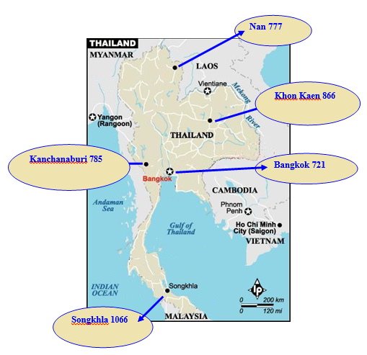
Figure 1. Number of study members and location of PCTC Study sites in Thailand

Demographic Characteristics
Among 4,544 infants, 50% were girls. 94.7% of infants followed the study at 6 months and 12 months. The mean age of mothers was 27.1 ± 6.3 years old. Other demographic characteristics are shown in table 1.

Table 1. Demographic characteristics presented as percentage unless specified otherwise

Characteristics | Total  (n) | Sites (%)
Characteristics | Total  (n) | North  (n=938) | Northeast  (n=1,228) | Central  (n=996) | South  (n=850) | Bangkok  (n=691)
Mothers
Age (years)
13 – 24 | 1,764 | 20.86 | 25.06 | 29.99 | 16.33 | 7.77
25 – 30 | 1,512 | 20.83 | 24.67 | 21.03 | 16.93 | 16.53
31 – 48 | 1,427 | 17.87 | 28.94 | 10.44 | 21.44 | 21.30
Mean ± SD | 27.1 ± 6.3 | 26.8 ± 6.3 | 27.6 ± 6.5 | 24.8 ± 5.4 | 27.9 ± 6.5 | 29.5 ± 5.9
Min - Max | (13 – 48) | (14 – 48) | (13 – 46) | (14 – 43) | (14 – 47) | (15 – 46)
Highest education
No education | 242 | 15.29 | 26.03 | 4.55 | 53.72 | 0.41
Primary | 2,315 | 25.40 | 32.35 | 27.21 | 10.41 | 4.62
High | 1,321 | 18.62 | 24.00 | 21.65 | 18.24 | 17.49
College | 374 | 13.90 | 15.51 | 10.96 | 23.53 | 36.10
No education | 454 | 6.47 | 8.84 | 5.39 | 32.33 | 46.98
Others | 10 | 10.00 | 20.00 | 30.00 | 30.00 | 10.00
Alcohol drinking
No | 4,253 | 20.01 | 26.05 | 21.51 | 18.36 | 14.06
Yes | 179 | 13.97 | 7.26 | 20.67 | 18.44 | 39.66
Income
Low | 1,566 | 15.58 | 38.31 | 25.93 | 19.67 | 0.51
Medium | 1,542 | 25.55 | 28.92 | 22.11 | 15.95 | 7.46
High | 1,527 | 20.04 | 11.20 | 15.95 | 17.29 | 35.49
Infants
Gender
Boys | 2,268 | 18.61 | 26.46 | 20.50 | 18.65 | 15.78
Girls | 2,276 | 19.73 | 26.19 | 20.52 | 18.37 | 15.20
Birth weight
Normal BW | 3,950 | 20.96 | 22.76 | 21.32 | 18.25 | 16.71
Low BW | 802 | 16.33 | 41.15 | 20.32 | 16.71 | 5.49
Gestational age
Normal GA | 4,027 | 20.88 | 24.06 | 19.84 | 19.22 | 15.99
Low GA | 725 | 16.28 | 35.86 | 28.41 | 11.17 | 8.28

Secondhand smoking in mothers among five sites
The average prevalence of SHS in pregnant women among five study sites was 46.76% (Table 2). The Northeast area has the highest prevalence of SHS during pregnancy (56.63%), while the lowest prevalence of SHS belonged to South region.

Table 2. Percentage of SHS in pregnant women among five study sites

Site | Number of SHS | Percentage of SHS
North | 437 | 45.90
Northeast | 683 | 56.63
Central | 530 | 53.16
South | 227 | 27.82
Bangkok | 257 | 45.17
Total | 2,182 | 46.76

Factors associated with DTE
Cox proportional regression analysis provided the effect of each characteristic on the outcome. Table 3 shows the crude hazard ratios of not having first tooth eruption in infants.

Table 3. Crude HR of not having first tooth eruption for each explanatory factor

Factors | Crude HR | 95%CI | P-value
SHS
No | 1.00 | Reference | 0.796
Yes | 0.99 | 0.93 – 1.06
Number of cigarettes of SHS | 1.00 | 0.99 – 1.00 | 0.643
Mother’s smoking
No | 1.00 | Reference | 0.362
Yes | 1.17 | 0.84 – 1.63
Number of cigarettes smoked by mothers | 1.02 | 0.99 – 1.05 | 0.206
Maternal age (years)
13 – 24 | 1.00 | Reference | 0.xxx
25 – 30 | 1.04 | 0.97 – 1.12
31 – 48 | 0.96 | 0.89 – 1.03
Child’s gender
Female | 1.00 | Reference | <0.001
Male | 1.17 | 1.10 – 1.25
Highest education of mothers
No education | 1.00 | Reference | 0.xxx
Primary | 0.87 | 0.75 – 1.00
High | 0.89 | 0.77 – 1.04
College | 0.93 | 0.78 – 1.11
University | 0.92 | 0.78 – 1.10
Income
Low | 1.00 | Reference
Medium | 1.03 | 0.95 – 1.11
High | 0.99 | 0.90 – 1.09
Birth weight
Normal BW | 1.00 | Reference | <0.001
Low BW | 1.19 | 1.09 – 1.29
Gestational age
Normal GA (>=37 weeks) | 1.00 | Reference | 0.006
Preterm birth (<37 weeks) | 1.13 | 1.04 – 1.24
Alcohol drinking during pregnancy
No | 1.00 | Reference | 0.855
Yes | 1.01 | 0.87 – 1.18

After adjusting for child’s gender, BW, GA, maternal age, income, alcohol drinking during pregnancy, and study site, SHS mothers were less likely to have children with the first tooth erupted than non-SHS mothers, although this result was not significant (adjusted HR = 0.98, 95% CI = 0.89 – 1.08, p value = 0.685) (Table 4 and 5).

Table 4. Adjusted HR of not having first tooth eruption for each explanatory factor

Factors | Adjusted HR | 95%CI | P-value
SHS
No | 1.00 | Reference | 0.685
Yes | 0.98 | 0.89 – 1.08
Number of cigarettes of SHS | 1.00 | 0.99 – 1.01 | 0.736
Mother’s smoking
No | 1.00 | Reference | 0.608
Yes | 1.41 | 0.38 – 5.16
Number of cigarettes smoked by mothers | 0.99 | 0.88 – 1.10 | 0.813
Maternal age (years)
13 – 24 | 1.00 | Reference | 0.xxx
25 – 30 | 1.02 | 0.94 – 1.11
31 – 48 | 0.93 | 0.85 – 1.01
Child’s gender
Female | 1.00 | Reference | <0.001
Male | 1.15 | 1.08 – 1.22
Highest education of mothers
No education | 1.00 | Reference | 0.xxx
Primary | 0.84 | 0.71 – 0.99
High | 0.85 | 0.72 – 1.01
College | 0.87 | 0.71 – 1.06
University | 0.93 | 0.76 – 1.13
Income
Low | 1.00 | Reference
Medium | 1.03 | 0.95 – 1.11
High | 0.99 | 0.90 – 1.09
Birth weight
Normal BW | 1.00 | Reference | 0.003
Low BW | 1.15 | 1.05 – 1.28
Gestational age
Normal GA | 1.00 | Reference | 0.521
Low GA | 1.03 | 0.93 – 1.15
Alcohol drinking during pregnancy
No | 1.00 | Reference | 0.613
Yes | 1.04 | 0.88 – 1.24

Table 5. Crude and adjusted hazard ratio of tooth eruption between smoking and non-smoking groups.

SHS status | Crude HR | 95% CI | Adjusted HR* | 95% CI
Non-SHS | 1.00 | Reference | 1.00 | Reference
SHS | 0.94 | 0.89 – 1.00 | 0.98 | 0.89 – 1.08
* Hazard ratio adjusted for child’s gender, maternal age, parents’ highest education level, income, BW, GA, and alcohol drinking during pregnancy, stratifying by study site.

Table 6 shows the crude OR of DTE with each factor. SHS mothers have the risk of DTE in infants 22% higher than the non-SHS mothers. DTE occurred in 16.00% females and in 22.16% male infants.

Table 6. Crude effect of each factor on DTE

Factors | Number | DTE (%) | Crude OR | 95% CI | p-value
SHS |  |  |  |  | 0.012
Yes | 2002 | 20.6 | 1.22 | 1.05 – 1.42
No | 2230 | 17.6 | 1.00
Mother’s education
No education | 227 | 16.3 | 1.00
Primary | 2137 | 20.7 | 1.34 | 0.93 – 1.94
High | 1228 | 19.5 | 1.24 | 0.85 – 1.81
College | 355 | 14.7 | 0.88 | 0.56 – 1.39
University | 458 | 14.9 | 0.90 | 0.58 – 1.38
Income
Low | 1444 | 22.71 | 1.00
Medium | 1442 | 17.61 | 0.73 | 0.61 – 0.87
High | 1440 | 17.29 | 0.71 | 0.59 – 0.85
Infant’s gender |  |  |  |  | < 0.001
Female | 2212 | 16.00 | 0.67 | 0.58 – 0.78
Male | 2202 | 22.16 | 1.00
Birth weight |  |  |  |  | < 0.001
Normal BW | 3711 | 17.70 | 0.61 | 0.51 – 0.74
Low BW | 726 | 26.03 | 1.00
Gestational age |  |  |  |  | 0.019
Normal GA | 3785 | 18.50 | 0.79 | 0.64 – 0.96
Preterm birth | 652 | 22.39 | 1.00
Study site
North | 822 | 15.21 | 1.00
Northeast | 1148 | 27.79 | 2.15 | 1.71 – 2.70
Central | 914 | 16.85 | 1.13 | 0.87 – 1.46
South | 834 | 16.67 | 1.12 | 0.86 – 1.45
Bangkok | 685 | 19.08 | 0.99 | 0.74 – 1.31
The hazard rate curve showed the difference in the probability of not having erupted tooth between SHS group and non-SHS group (Figure 2), and between females and males (Figure 3).

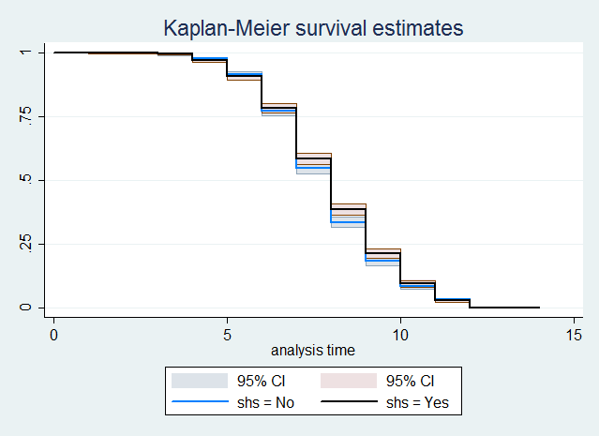

Figure 2. Difference in the probability of not having erupted tooth between SHS and non-SHS group

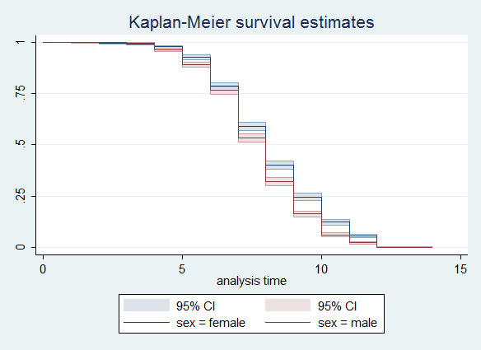

Figure 3. Difference in the probability of not erupted tooth between females and males

DISCUSSIONS
This study evaluated the association between SHS during pregnancy and the time of first tooth eruption. We found that the time of first tooth eruption was delayed in SHS women. This can be explained by the mechanism where smoking can increase the amount of calcium that goes out of the body, resulting hypocalcemia . Once hypocalcemia occurs, it may have an effect on dental calcification. It occurs when the infant body cannot accumulate calcium and phosphate or does not absorb enough during the last three months of pregnancy . Our ﬁndings are consistent with other previous studies when suggesting a positive association between SHS and delayed formation of child’s teeth. SHS could be much more serious than primary smoking in mothers during pregnancy .
We also found the association between social economic status of parents including income and education level and the development with tooth eruption, although this association was not significant. This finding is similar with the study of Adler et al. . Those families who have low income and are not well-educated might have not provided sufficient nutrition to their infants, especially calcium deficiency, affecting to the formation of tooth enamel in both primary and permanent teeth .
Maternal age is also related to the time of eruption of the first tooth, especially the young mothers. They may lack of physical maturity. Moreover, they themselves are developing, so the development of the infants may be competing with them .
Birth weight and preterm birth were also related to the time of tooth eruption, as mentioned in many previous studies . Study of Negar and Fadavi suggested that infants with higher BW had earlier time of deciduous tooth eruption, whereas study of Lawoyin et al. proved the opposite relationship between BW and time of first tooth eruption. Infants with preterm birth and low BW may lack of vitamin D absorption resulting in reduction of calcium and phosphate intake. This could lead to insufficient nutrients among those infants, thus they are lack of dental calcification necessary for the formation of their first dentition.
There was a difference between girls and boys regarding the time of first tooth eruption. A previous study in Uganda also showed a similar result that girls have shorter time of tooth eruption than boys about half year . While resent study of Kutesa has found an earlier time (0.8 year) in girls comparing to boys. This gender-relationship has still not known much yet until now, however, some authors assumed that this differences was due to the differences in sexual maturity or embryologic timing .

Strengths of the study
This study is a strongest observational design which can investigate multiple risk factors for delayed first tooth eruption. Besides, this study used data from PCTC project which is a very large birth cohort study in Thai population, therefore this sample can be a national representative. Another strength of this study is the minimal loss to follow-up.
Limitations of the study
Although having several strengths described above, this study also had some limitations that might distort the findings. Firstly, to overcome information bias in the main PCTC study, we trained and calibrated the interviewers. Another type of bias that may occur in this study is potential confounding factors. We have made our efforts to control for several possible confounders which were listed in table 1 by adjusting in data analysis process.
Causal inferences are still suspect in this recent study as this is a part of PCTC, a cohort study design. Also, this study does not allow us to see the change of association over time.
Conclusions and recommendations
In summary, our findings suggested that secondhand smoking in Thai pregnant women was associated with delayed time of the first tooth eruption in infants up. This may lead to many problems in the dental and nutritional development of infants. Further studies on this topic in other population should be conducted in the future to achieve much more evidences in order to help the policy-makers eliminate this burden.

Acknowledgements
This study was based upon the PCTC project supported by the National Ethics Committee of the Ministry of Public Health of Thailand and Khon Kaen University.

Conflict of interests
None declared.

Funding
This study was funded by …

REFERENCES

