TITLE PAGE

Title: Relationship between secondhand smoking in pregnant women and the time of first tooth eruption in infants.
Authors: Vu Hoa Anh Dien¹, Bandit Thinkhamrop² , <Others to be added>
Affiliations:
¹ Department of Community Dentistry, Faculty of Dentistry, Khon Kaen University, Thailand
² Department of Biostatistics and Demography, Faculty of Public Health, Khon Kaen University, Thailand
Corresponding authors:
Name: Bandit Thinkhamrop
Address: Department of Biostatistics and Demography, Faculty of Public Health, Khon Kaen University, Khon Kaen, 40002, Thailand
Telephone: +66-85-0011123
Fax: +66-43-362075
E-mail: bandit@kku.ac.th
Type of contribution: Original research results
Running title: Secondhand smoking and first tooth eruption
Number of words in the abstract: 279
Number of words in the text: 2,657
Number of tables: 6
Number of figures: 3

ABSTRACT

Background: The deciduous teeth are very important to the development of infants in terms of speaking, chewing and holding space for the permanent teeth. Smoking is very common in Thai people, especially males. Women and children are also affected by their behaviors. There are not many studies examining the association between secondhand smoking in pregnant women and the time of first tooth eruption.
Objective: To evaluate the association between secondhand smoking in pregnant women and delayed time of first tooth eruption in infants.
Methods: Data from the Prospective Cohort Study of Thai Children (PCTC) was used to record the exposure of secondhand smoking in pregnant women. Children was followed from three months of age until the time of first tooth eruption. PCTC is a large birth cohort study which was conducted from in 4,300 infants from the 28th week of gestation to 24 years of age and their parents or caregivers in five different regions in Thailand. Linear regression analysis and Cox regression analysis will be applied using Stata SE 12.0.
Results: The mean age of first tooth eruption was x.xx ± x.xx months. xx.xx% of xxxx subjects are secondhand smokers during the third trimester of pregnancy. The risk of having delayed first tooth eruption among secondhand smoking mothers is x.x times higher than that among non-smokers (95% confidence interval x.x – x.x). Infants of mothers who are secondhand smokers have the time of first tooth eruption x.x weeks (95% confidence interval x.x – x.x) later than those of non-smokers.
Conclusion: Secondhand smoking in Thai pregnant women delayed the time of the first tooth eruption in infants up to x.x weeks.
Keywords: Deciduous teeth, eruption, secondhand smoking, Thai pregnant women, infant

INTRODUCTION
Delayed first tooth eruption (DTE) can cause many problems in the development of infants because deciduous teeth not only help to hold space in the jaws for the permanent teeth and align them into correct position , but also permit infants to chew and speak properly. There are many factors which may influence the time of tooth eruption including genetics, gender, ethnicity, social economic status, nutrition , and neonatal factors . Moreover, tooth eruption time has been shown differently among different races . However, role of secondhand smoking (SHS) on DTE has not yet been broadly established.
Many studies have reported the negative effect of smoking during pregnancy on the children , particularly on the time of first tooth eruption . Smoking is very common in Thai people, especially among males. Women and children are also affected by their behaviors. This leads to a high prevalence (29.8%) of secondhand smoking exposure among Thai women .
Being aware of such risk factors, we could help improve the dental development of infants. However, little was known about this association in Thai population. Hence, we conducted this study to determine whether secondhand smoking during pregnancy period delayed the time of first tooth eruption in Thai infants.

MATERIALS AND METHODS

Study design
This paper is a part of the Prospective Cohort Study of Thai Children (PCTC). The PCTC is a large birth cohort study which was conducted by Dr. Chanpen Choprapawon and colleagues on 4,300 infants from the 28th week of gestation to 24 years of age and their parents or caregivers in five different regions in Thailand . Participants were recruited from one selected district in each of four regions (including the North (Nan province), Northeast (Khon Kaen province), Central (Kanchanaburi), and South (Songkla province) of Thailand) and Bangkok. These samples had to meet the criteria including being accessible year-round, 800 to 900 newborns on average each year, all residents intend to live in the study area for at least 5 years, and having a long-term commitment with the project by a hospital director (and associates). The babies who were born between October 15, 2000 and September 14, 2002 were recruited in the study. Data were collected not only from mothers, fathers, other family members and children, but also from secondary data regarding community and demographic variables. Many methods of data collection were used in PCTC study like in-person interview, diary records, medical records, and extraction from existing data.
All participants signed the written informed consent after obtaining verbal permission. PCTC project was approved by the National Ethics Committee of the Ministry of Public Health of Thailand. This study was approved by the Khon Kaen University Ethics Committee for Human Research.

Independent variables and outcomes
This study focused on the secondhand smoking (SHS) status of pregnant mothers during pregnancy and the time of first tooth eruption in infants. The smoking status were defined by a binary variable (yes/no). The number of cigarettes was also recorded and classified into three groups: no smoking during pregnancy, 1 to xx cigarettes smoked per day on average (<50th percentile) during pregnancy, and more than xx cigarettes smoked per day on average (≥50th percentile) during pregnancy.
Main binary outcome was the time of first tooth eruption in infants which was extracted from the PCTC. Delayed tooth eruption (DTE) is defined when the first tooth erupts in 9th month after birth. The secondary outcome was time to eruption of the first tooth in infants.

Potential bias
Other demographic variables were also taken into account for controlling potential bias including parents’ education level, mother’s age, child’s gender, and birth weight (BW). Imputation method was applied to handle unavoidable missing data.

Statistical analysis
Description analysis were utilized to describe the baseline characteristics of infants and their families. Crude odds ratios were estimated for SHS during pregnancy and having DTE. Pearson regression was used to determine the relationship between the time of first tooth eruption and the number of cigarettes smoked by the fathers. Logistic regression modeling was used to test for a dose-response trend, odds ratios (ORs), and their 95% confidence intervals (95%CIs) of factors that affect time of first tooth eruption, adjusting for baseline characteristics. Cox proportional regression was used to estimate the hazard ratio (HR) of DTE between the SHS mothers and the non-SHS ones. A generalized estimating equation (GEE) framework was used to account for the cluster data. All data were analyzed using Stata SE statistical software version 12.0 (Stata Corp, College Station, TX). A p-value of less than 0.05 was set as a statistically significant level for all tests.

RESULTS
A total of 4,215 families from five different areas were participants in this study (Fig. 1).
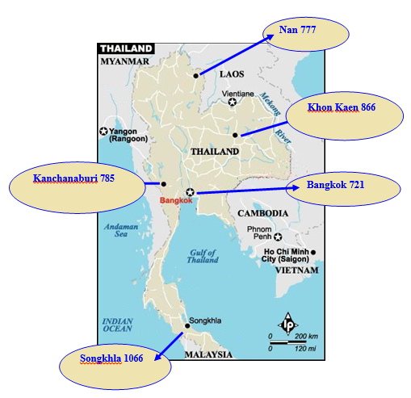
Figure 1. Number of study members and location of PCTC Study sites in Thailand

Demographic Characteristics
Among xxxx infants, xx% were girls. The mean age of infants were xx.x±x.x years old (ranged: xx-xx). The mean age of mothers, fathers, and caregivers were xx.x±x.x, xx.x±x.x, and xx.x±x.x years old, respectively (Table 1).
Table 1. Demographic characteristics presented as percentage
Characteristics | Total  (n=xxxx) | Sites
Characteristics | Total  (n=xxxx) | North  (n=xxx) | Northeast  (n=xxx) | Central  (n=xxx) | South  (n=xxx) | Bangkok  (n=xxx)
Mothers
Age (years)
≤ 29
30 – 39
40 – 49
≥ 50
Mean ± SD
Range
(Min - Max)
Highest education
Middle school
High school
Bachelor’s degree
Master’s degree
Doctoral degree
Others
Fathers
Age (years)
≤ 29
30 – 39
40 – 49
≥ 50
Mean ± SD
Range
(Min - Max)
Highest education
Middle school
High school
Bachelor’s degree
Master’s degree
Doctoral degree
Others
Caregivers
Age (years)
≤ 29
30 – 39
40 – 49
≥ 50
Mean ± SD
Range
(Min - Max)
Highest education
Middle school
High school
Bachelor’s degree
Master’s degree
Doctoral degree
Others
Infants
Genders
Boys
Girls
Birth weight
Normal birth weight
Low birth weight (<2500g)

Secondhand smoking in mothers among five sites
The average prevalence of secondhand smoking in pregnant women among five sites was xx.xx% (95% CI xx.xx – xx.xx) (Table 2).
The [name] area has the highest prevalence of SHS during pregnancy (xx.xx%), while the lowest prevalence of SHS belonged to [name] region of Thailand.
Table 2. Prevalence of secondhand smoking in pregnant women
Site | Number of SHS | Prevalence of SHS | 95% CI
North
Northeast
Central
South
Bangkok

Factors associated with delayed tooth eruption
Cox proportional regression analysis provided the effect of each characteristic on the outcome (Table 3). First tooth erupted after 9 months old (meaning delayed first tooth eruption) in xx.x% females and in xx.x% males.
Table 3. Crude hazard ratios (HR) of having delayed first tooth eruption for each explanatory factor
Factors | Number of DTE | % DTE | Crude HR | 95%CI | P-value
Maternal age (years)
≤ 29 | xxx | xx.x | 1.00 | Reference | 0.xxx
30 – 39 | xxx | xx.x | x.xx | x.xx – x.xx
40 – 49 | xxx | xx.x | x.xx | x.xx – x.xx
≥ 50 | xxx | xx.x | x.xx | x.xx – x.xx
Child’s gender
Female | xxx | xx.x | 1.00 | Reference | 0.xxx
Male | xxx | xx.x | x.xx | x.xx – x.xx
Highest education of mothers  Middle school | xxx | xx.x | x.xx | x.xx – x.xx
High school | xxx | xx.x | 1.00 | Reference | 0.xxx
Bachelor’s degree | xxx | xx.x | x.xx | x.xx – x.xx
Master’s degree | xxx | xx.x | x.xx | x.xx – x.xx
Doctoral degree | xxx | xx.x | x.xx | x.xx – x.xx
Others | xxx | xx.x | x.xx | x.xx – x.xx
Birth weight
Normal BW | xxx | xx.x | 1.00 | Reference | 0.xxx
Low BW | xxx | xx.x | x.xx | x.xx – x.xx
Alcohol drinking during pregnancy
No | xxx | xx.x | 1.00 | Reference | 0.xxx
Yes | xxx | xx.x | x.xx | x.xx – x.xx
Caffeine consumption during pregnancy
No | xxx | xx.x | 1.00 | Reference | 0.xxx
Yes | xxx | xx.x | x.xx | x.xx – x.xx

After adjusting for child’s gender, maternal age, birth weight, alcohol drinking and caffeine consumption during pregnancy, and study area, SHS mothers with more than xx cigarettes per day (≥ 50th percentile) were more likely to have children with DTE than non-SHS mothers (adjusted HR = x.xx, 95% CI = x.xx – x.xx, p value = 0.xxx) (Table 4).

Table 4. Crude and adjusted hazard ratio of DTE between levels of smoking groups and non-smoking group.
SHS level | DTE |  | Not DTE |  | Crude HR |  | Adjusted HR*
SHS level | n | % | n | % | HR | 95% CI | HR | 95% CI
Non-SHS | xx | xx.xx | xx | xx.xx | 1.00 | Reference | 1.00 | Reference
SHS ≥ 50th percentile | xx | xx.xx | xx | xx.xx | x.xx | x.xx, x.xx | x.xx | x.xx, x.xx
SHS < 50th percentile | xx | xx.xx | xx | xx.xx | x.xx | x.xx, x.xx | x.xx | x.xx, x.xx
* Hazard ratio adjusted for child’s gender, maternal age, parents’ highest education level, birth weight, and alcohol drinking and caffeine consumption during pregnancy.

Comparison of DTE among five study areas
The rate of DTE was highest in [name of area] area, comparing with other regions (Table 5).

Table 5. Odds ratio of having DTE among five study sites

Area | Number | % DTE | Crude OR | 95%CI | p-value
North | xxx | xx.x | 1.00 | Reference | 0.xxx
Northeast | xxx | xx.x | x.xx | x.xx – x.xx
Central | xxx | xx.x | x.xx | x.xx – x.xx
South | xxx | xx.x | x.xx | x.xx – x.xx
Bangkok | xxx | xx.x | x.xx | x.xx – x.xx

Time to eruption of the first tooth
Figure 2 showed the relationship between the number of cigarettes smoked by the fathers and the time of first tooth eruption. From the number of cigarettes fathers smoked, time of first tooth eruption can be predicted by this equation y = a + bx, where x is the number of cigarettes and y is the time of first tooth eruption.
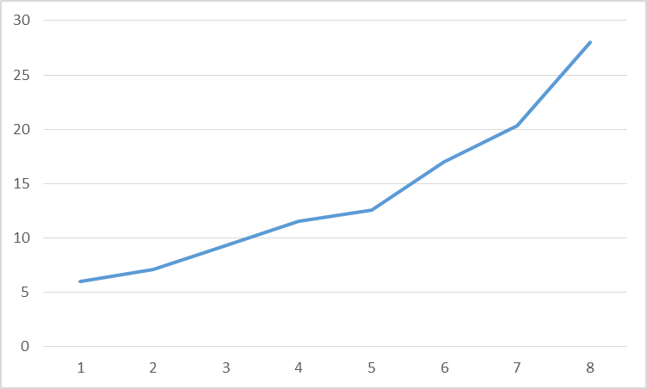

Figure 2. Positive association between the number of cigarettes smoked by the fathers and the time of first tooth eruption

Cox proportional regression showed the estimated HR of DTE (HR = x.xx, 95% CI x.xx – x.xx, p-value = 0.xxx) between the SHS mothers and the non-SHS ones (Table 6).

Table 6. Hazard ratios of having DTE between SHS and non-SHS groups
SHS status | DTE |  | Not DTE |  | HR | 95% CI
SHS status | n | % | n | % | HR | 95% CI
Non-SHS | xx | xx.xx | xx | xx.xx | 1.00 | Reference
SHS | xx | xx.xx | xx | xx.xx | x.xx | x.xx – x.xx

The hazard rate curve showed the difference in the probability of DTE between SHS group and non-SHS group (Figure 3).

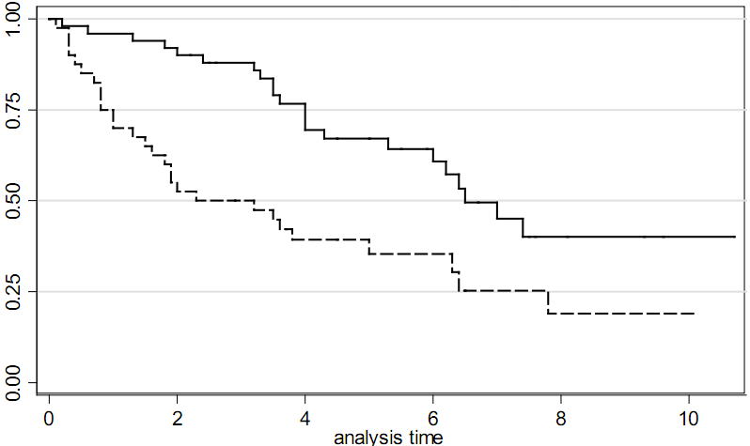

Figure 3. Difference in the probability of DTE between SHS group and non-SHS group

DISCUSSIONS
This study evaluated the association between SHS during pregnancy and the time of first tooth eruption. We found that the time of first tooth eruption was delayed in SHS women during pregnancy. This can be explained by the mechanism that … [biological plausible]
Our ﬁndings are consistent with other previous studies when suggesting a positive association between second hand smoking and delayed formation of child’s teeth. Secondhand smoke could be much more serious than primary smoking in mothers during pregnancy.
We also found the association between social economic status of parents including income and highest education level and the development with tooth eruption, although this association was not significant. This finding is similar with the study of Adler et al. . Those families who have low income and are not well-educated might have not provided enough nutrition to their infants, affecting to the formation of tooth crown, especially calcium resources.
Birth weight was also related to the time of tooth eruption, as results of the studies of Niswander in Japan and Kutesa in Uganda . Study of Negar and Fadavi suggested that infants with higher BW had earlier time of deciduous tooth eruption, whereas Lawoyin et al. proved the opposite relationship between BW and time of first tooth eruption.
There was a difference between girls and boys regarding the time of first tooth eruption. A previous study in Uganda also showed a similar result that girls have shorter time of tooth eruption than boys about half year . While resent study of Kutesa has found an earlier time (0.8 year) in girls comparing to boys. This gender-relationship has still not known much yet until now, however, some authors assumed that this differences was due to the differences in sexual maturity .
Strengths of the study
This study is a strongest observational design which can investigate multiple risk factors for delayed first tooth eruption. Besides, this study used data from PCTC project which is a very large birth cohort study in Thai population, therefore this sample can be a national representative. Another strength of this study is the minimal loss to follow-up.
Limitations of the study
Although having several strengths described above, this study also had some limitations that might distort the findings. Firstly, to overcome information bias in the main PCTC study, we trained and calibrated the interviewers. Another type of bias that may occur in this study is potential confounding factors. We have made our efforts to control for several possible confounders which were listed in table 1 by adjusting in data analysis process.
Causal inferences are still suspect in this recent study as this is a part of PCTC, a cohort study design. Also, this study does not allow us to see the change of association over time.
Conclusions and recommendations
In summary, our findings suggested that secondhand smoking in Thai pregnant women was associated with delayed time of the first tooth eruption in infants up. This may lead to many problems in the dental and nutritional development of infants. Further studies on this topic in other population should be conducted in the future to achieve much more evidences in order to help the policy-makers eliminate this burden.

Acknowledgements
This study was based upon the PCTC project supported by the National Ethics Committee of the Ministry of Public Health of Thailand and Khon Kaen University.

Conflict of interests
None declared.

Funding
This study was funded by …

REFERENCES

